|  |
| --- |
| UNICEF Nepal Country office |
| Strategies and Options for Scaling up and Enhancing the Child Grant Nationally in Nepal |
|  |
|  |
| **Amjad Rabi**  **Gabriele Koehler**  **Tomoo Okubo**  **Thakur Dhakal** |
|  |

|  |  |
| --- | --- |
| |  | | --- | |  | |

**ACKNOWLEDGEMENTs**

First of all, the authors would like to express their gratitude to the following government officials for their valuable insights and participation in the technical meeting to discuss this paper: Dr. Yangya Bahadur Karki (Member of National Planning Commission), Dr. Swarnim Wagle (Member of National Planning Commission), Dr. Som Lal Subdei (Secretary, Ministry of Federal Affairs and Local Development), Mr. Biswa Nath Dhakal (Joint Secretary, Ministry of Labour and Employment / Executive Director, Social Security Fund), Mr. Shankar Nepal (Under Secretary, Ministry of Federal Affairs and Local Development). The authors would also like to thank the following persons for the substantive comments and feedback: Martin C. Evans (UNICEF New York), Jessica Hagen-Zangker (Overseas Development Institute), Nicholas Mathers (London School of Economics) and Alberto Minujin (The New School for Public Engagement). The authors are grateful for the support and direction received from Tomoo Hozumi, Representative, UNICEF Nepal.

The findings, interpretations and conclusions expressed in this paper are those of the authors and do not necessarily reflect the policies or views of UNICEF or of the United Nations.

**Executive Summary**

The objective of the study is to offer to the Government of Nepal (GoN) a set of reflections and options regarding the continuation, scale-up and enhancement of the Child Grant (CG), a cash transfer program for children under the age of 5 introduced by the GoN in 2009. While the original intention was to cover all children nationally, the first phase of implementation was geographically targeted to all children in five Karnali districts, which are the poorest in the country, and to under 5 children from poor Dalit families across the country.

The context of this paper is the National Social Protection Framework, which the GoN is in the process of finalization. This framework uses the life-cycle based social protection floor approach, and posits a right to social protection for all. CG is integral to this approach as it covers income security and social protection for children and families.

Evidence suggests that the CG has been effective. In the Karnali Zone where it is designed to reach all children under 5 (with a cap of two children per family), the coverage rate reached almost 80 per cent and it has led to a phenomenal increase in birth registration to 90 per cent compared to the national average of 42 per cent.

On the other hand, the first round of evaluations suggests that the benefit level under the CG program of NRs 200 (USD $2) per child per month is too small to have any durable impact on family income. Another limitation is that it is universal only in the Karnali region, albeit the poorest region of Nepal, and limited to low-income Dalit families in the other regions.

This study therefore proposes an enhancement of the CG in two ways: in terms of the coverage, a government decision to universalize the CG to reach all children as quickly as feasible; with regards to the design of the program, an increase in the benefit level and improvements in delivery and monitoring. Conceptually, the argument for a universal coverage stems from the United Nations Convention on the Rights of the Child, the Universal Declaration of Human Rights, the Covenant on Economic, Social and Cultural Rights as well as from the commitments made in other government policy statements. In light of the intersecting inequalities facing children, the case for universalization also derives from the difficulty to single out particularly disadvantaged communities, or to limit the grant only to the lowest wealth quintiles, as the majority of the population lives close to the $2 poverty line.

In order to show the economic rationale and fiscal viability of this proposal, the study provides a detailed costing of a variety of conceivable options and its combinations. One set of options is to maintain the current age limit (under the age of 5), but to expand nationally to all children and increase the benefit amount. Another set of options is to modify the age criterion to the first 1000 days (i.e. from pregnancy to age 2) - the period of greatest vulnerability for the survival and development of children and possibly increase the benefit amount. The cost for each option is projected taking into crucial fundamental factors such as changes in demography, inflation and economic growth. Analysis of the fiscal envelope presents several options to create additional fiscal space for the scale-up.

From an impact point of view, a universalized CG with a higher benefit level would be more effective than the current CG. From a policy coherence point of view, it could be the cornerstone of Nepal’s National Framework for Social Protection. From a child- rights point of view, it is imperative.

**Table of Contents**

1. Introduction 7

**1.1.** **Study Objective and Overview** 7

**1.2.** **Social Protection – Definitions and the Global Debate** 8

**1.3.** **The Political Economy of Social Protection** 9

**1.4.** **Providers and Scope of Social Protection in Nepal** 11

**1.4** **Government Commitments and Engagement in Social Protection for Children** 12

2. SocioEconomic backDROP of SOCIAL Protection in nepal 15

**2.1** **Overview** 15

**2.2** **Demographic Profile** 15

**2.3**  **Macroeconomic Profile** 17

**2.4**  **Poverty and Hunger Profile** 18

3. The Child grant Program in Nepal: CURRENT Status and INITIAL outcomes 23

**3.1** **Overview** 23

**3.2** **Extent of Coverage** 23

**3.3** **Implementation Mechanism** 24

**3.4** **Challenges and Constraints** 24

4. Impact of the child grant 27

**4.1** **Impact on Birth Registration** 27

**4.2** **Impact on non-income dimensions – international experience** 28

**4.3**  **Impact on Economic Growth** 29

5. INTRODUCING IMPROVED CHILD GRANTS OPTIONS 30

**5.1.** **Scaling Up Scenarios** 30

**5.2.** **Conditionality and Targeting** 31

**5.3.** **Methodology of the Costing of the Proposed System** 32

**5.4.** **Projection Assumptions and Results** 33

6. ASSESSING THE Fiscal Space 39

**6.1** **Improved Taxation** 40

**6.2.**  **Reprioritization of expenditures** 42

**6.3**  **More accommodating macroeconomic framework** 46

**6.4**  **Using fiscal and central bank foreign exchange reserves** 47

**6.5.** **Increased aid and transfers** 48

7. policy recommendations and way forward 50

**7.1**  **Strategies Towards Universalization** 50

**7.2**  **Monitoring and Evaluation** 51

**7.3** **Conclusion** 52

**List of TableS**

Table 1 Population Change in thousands, 1980 – 2010 15

Table 2: Main Economic Indicators, 2004-2013 18

Table 3: Nutritional Status by Wealth Group 21

Table 4: Child Grant Scaling Up Scenarios 31

Table 5: Population Projection (Medium Variant) Main Characteristics, 2014 - 2020 33

Table 6: Benefit Amount in Current Local Currency and as a percentage of Food poverty line (2014) and Per Capita GDP, 2014-2020 35

Table 7: Total Expenditure of all Scenarios in Billion NRs, as a percentage of GDP, and as a percentage of Government Expenditure, 2014-2020 36

Table 8: National Budget in Billion Nepali Rupees (NRs.) and as a Percent of GDP, 2012/13-2014/15 40

Table 9: Budget Revenues (Tax and non-Tax) as a per cent of GDP for Nepal and Comparator Regions 41

Table 10: Summary Results from the Projection of Costs and Number of Beneficiaries 50

**List of Figures**

Figure 1 Major Components of Social Protection 8

Figure 2: Social Protection Index in Asia and the Pacific 12

Figure 3 Total Fertility Rates, 1980-2010 16

Figure 4 Population Pyramid, 1980-2050 16

Figure 5 Population Growth Rates by Major Age Groups, per cent, 2000-2010 17

Figure 6: Millennium Development Goals Indicators 19

Figure 7: Household Poverty Rates by Number of Children in the Household, 2010/11 20

Figure 8: Actual Amount of Child Grant Received per Child, Annually, 2013 25

Figure 9 Birth Registration Rate in South Asia 27

Figure 10: Projection Model Components and Dependency Structure 33

Figure 11: Population Growth Rates by Major Age Groups, 2010-2030 34

Figure 12: Macroeconomic Model’s Assumptions- GDP Growth Rate and CPI Rate 34

Figure 13: Beneficiaries in Thousands, 2014-2020 35

Figure 14: Total Expenditure of all Scenarios in Billion NRs and as a percentage of GDP (right axes). 2014 37

Figure 15: Total Expenditure of all Scenarios in Billion NRs and as a percentage of GDP (right axes), 2020 37

Figure 16: Different Taxes as a per cent of total Taxes, Budget Fiscal Year 2014/5 41

Figure 17: Different Taxes and Inflation Growth Rates (Base year is 100 in 2012/13) 42

Figure 18: Public Spending as a per cent of Total Spending, Economic Classification, 2014/15 43

Figure 19: Nominal, Real-Term, and Per Capita Growth Rates in National Budget between Fiscal Year 2013/14 and 2014/15. 44

Figure 20: Public Spending Functional Classification as A per cent of Overall Spending and as a per cent of GDP, Fiscal Year 2014/15 45

Figure 21: Expenditure on Health as a per cent of GDP and in Per Capita USD, 2009 45

Figure 22: Distribution of the Social Protection Allocation across the Different Programs, 2014/15. 46

Figure 23: General Government Gross National Debt as a per cent of GDP, 2013 47

Figure 24: Workers' Remittances and Gross Official Reserves, Millions USD, 2010/11- 2014/15 48

Figure 25: Grants Billion Nepali Rupees (NRs.) and as a per cent of GDP, 2012/13-2014/15 48

1. **Introduction**
   1. **Study Objective and Overview**

The objective of the study is to offer to the Government of Nepal (GoN) a set of strategies and options regarding the continuation, scaling-up and enhancement of the Child Grant, a cash transfer program introduced by the GoN in 2009. This is in light of the Government’s policy commitments and the country’s political and socio-economic situation. The Child Grant is situated in the context of social protection and child-sensitive policy-making, directly building on the United Nations Convention on the Rights of the Child (CRC) and the ILO Recommendation on Social Protection Floors, as well as national-level commitments in Nepal’s Interim Constitution, the Interim Plan 2010-13, and the Thirteenth Plan 2013/14-15/16 (GoN 2010; ILO 2012; GoN 2013). The proposal is to integrate an enhanced Child Grant into the goal of minimum social protection for all in the context of the National Framework for Social Protection (GoN 2013). The proposals offered are grounded in a child rights approach.

A reliable and effective Child Grant - with appropriate benefit levels, timely payment, and wider - or ideally universal - national coverage - is likely to reduce poverty and have a positive impact on human development, notably health, education and nutrition. Most importantly, it can improve child wellbeing and fight child poverty. In addition, it can promote universal birth registration, thereby strengthening civil registration and vital statistics which in turn are foundations of good governance.

The study therefore makes a strong case for continuing and improving the grant in two ways. This is firstly in terms of the coverage, by moving towards its universalization. Such an approach is anchored in the rights-based argument that all children in the country ought to be benefiting from a Child Grant. Universal coverage would be an optimal approach also in light of the large share of children affected by poverty and malnutrition, the wide range of causes behind inequities, and the lack of administrative capacity to identify the poor. Universal coverage is moreover central to the social protection floor framework which the government is currently developing. Secondly, the case for enhancing the current grant is made at the design level, in terms of increasing the benefit levels, possibly revising the age period coverage for pregnancy and improving delivery modalities and checks and balances, as fiscal space and administrative capacities expand. Both aspects together would contribute to significantly improving the situation of children in Nepal.

These recommendations build on a review of the preliminary outcomes and observed shortcomings of the current Child Grant. The study sketches out various options for an enhanced Child Grant, providing calculations on the respective costs of each potential option, and selected combinations. An impact assessment models the potential effects on poverty indicators. The study also discusses options for expanding fiscal space, which is a corollary to enhancing the Child Grant programme in a sustainable and equitable fashion. We believe that our study provides solid evidence for the policy makers to revisit the Child Grant, and decide on strategies for further enhancement and scale-up.

Chapter 1 introduces the concept of social protection from a global perspective, as well as in the context of Nepal. The commitments of the GoN to social protection for children are also reviewed. Chapter 2 gives a brief outlook of the demographic status and socioeconomic background of Nepal. Both the opportunities and the challenges facing the country point to the crucial role of a universal social protection system. We review the current Child Grant scheme, the implementation mechanism, and some challenges faced in the past years in Chapter 3. This is followed by a discussion on the impact of the Child Grant based on national and international evidence presented in Chapter 4. Based on the discussion of constraints and challenges of the current scheme, Chapter 5 provides several options on how to enhance the current scheme and offers cost estimates for each option. Chapter 6 offers a fiscal space analysis. In the last Chapter, the study comes to the conclusion that an enhanced Child Grant would be in line with the Government’s commitments to child rights, would be economically and fiscally feasible and sound, and politically desirable.

* 1. **Social Protection – Definitions and the Global Debate**

Definitions and terminology used in discussing social protection have evolved over time and tend to differ slightly among different schools of thought. Social protection is generally understood as the combination of social insurance – (i.e. contributory forms of social provisioning) and social assistance (i.e. transfers which cover wide chapters of the population), and are generally funded from public sources (ILO 2012) (see figure 1). [1] A broader understanding refers to social protection as the set of public and private policies and programmes aimed at preventing, reducing and eliminating economic and social vulnerabilities to poverty and deprivation (UNICEF 2012). A life-cycle approach posits social protection in the three phases of life - infant and childhood, adulthood and working life, and old age - with access to health services as a component accompanying all three phases. This framework is used in the social protection floors initiative adopted in ILO Recommendation 202 and the GoN has committed to introducing the social protection floor (ILO 2012, NSCSPF 2011).

Figure Major Components of Social Protection

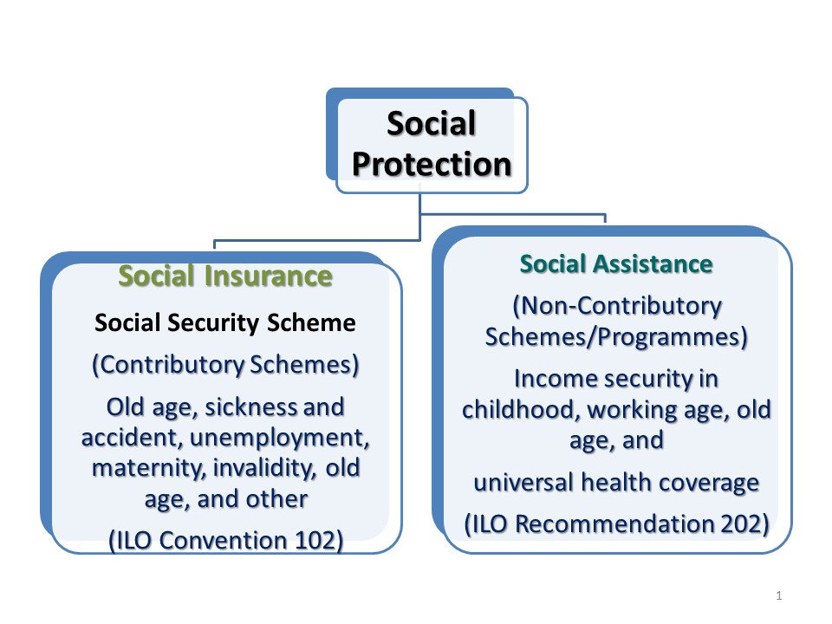

Source: Based on the ILO definition of Social Protection (ILO 2012)

One can identify a range of instruments of social protection:

* Social cash transfers;
* Programs to ensure economic and social access to education, health, water and sanitation and other social services;
* Social support services such as care facilities;
* Legislation and policies to ensure child rights, equity and non-discrimination in children’s and families’ access to services and employment/livelihoods (UNICEF 2012).

The Child Grant discussed in this study falls under the social cash transfer component. Social cash transfers are defined as flows of money to households to alleviate household poverty, hunger or malnutrition, and achieve other social outcomes. The grants are generally designed to address income insecurity, avert or protect from risk, and give greater freedom of choice in consumption decisions. In some countries, as mentioned above, they are also meant to enhance social inclusion (Adhikari et al., 2014). Although the benefit amounts in most schemes found in low-income countries tend to be small, they have nevertheless demonstrated some positive effects on food consumption, diet diversity, and expenditures on health and education (Adhikhari et al., 2014).

* 1. **The Political Economy of Social Protection[2]**

Some form of universal social protection coverage has been in place in most higher-income countries since the 1950s, in the context of their post- World War II welfare state arrangements (Esping-Andersen 1990). While most low income countries have featured social security for the formal sector since their independence, broader forms of social protection covering rural populations and the informal economy was introduced in waves. The Latin American examples of large-scale programmes such as *Bolsa Familia* (the Family Grant) in Brazil, and *Oportunidades* (opportunities) programme in Mexico have been in place in various forms since the 1990s, as a response to cushion the economic and social impacts of structural adjustment programmes.

In Asia and the Pacific, the Asian financial crisis of 1997/98 prompted many middle-income countries in the region to revisit and upgrade their social protection systems, as the middle classes were massively affected by loss of incomes and employment, the folding of enterprises, and rising costs of living as a result of currency devaluations. These were political responses to growing social issues. Moreover, at the time, beyond its role as a safety net, social protection was presented as a macroeconomic stabilizer, with the argument that the higher propensity to consume of lower income quintiles would increase aggregate demand and revitalize an economy in recession.

The introduction or upgrading of social protection as crisis responses was the first wave. Recently, the discourse has moved on into a more normative mode, with progressive governments, Civil Society Organizations, academics and multilateral agencies make a case for social protection from a rights-based angle. The recent decade has in fact seen a surge in social protection: research suggests that nearly 100 countries across the world have constituent elements of social security in place and more than 50 low-income countries have introduced social assistance (ILO 2014; United Nations 2013).

South Asia has been a forerunner in rights-based social protection. Since 2004/5, one country after another began expanding and systematizing social protection, and introduced large-scale social assistance programmes. Cases in point are employment guarantee schemes such as the Mahatma Gandhi National Rural Employment Guarantee Act (MGNREGA) in India, social pensions and rural health insurance schemes in India, Nepal, Maldives, or the Child Grant in Nepal. The issues addressed in these programmes include income poverty and malnutrition, but also social exclusion, which is an element in social protection that programmes in other regions do not feature. The drivers of these innovative social protection schemes have been a combination of government policy, and civil society pressure, notably large-scale informal sector movements in India. There is also an element of political competition, with successive governments wanting to improve on their predecessors’ social policy commitments, and neighbouring countries transporting successful or popular interventions, such as the employment schemes.

At the global level, many of the multilateral agencies have been promoting the right to social protection. In 2012, the ILO annual conference adopted the Recommendation on the Social Protection Floors (R 202), which is now being vetted in numerous countries (ILO 2012). It uses the life cycle approach. Many analysts and advocates have shown how child-oriented social protection is particularly important (see box 1).

Other notable examples include the work of the Special Rapporteurs of the Office of the High Commissioner on Human Rights (Sepulveda and Nyst 2012; Alston 2014), and the policy positions of the ADB (Handanyani 2010; ADB 2013; ESCAP 2011a). Most multilateral agencies have social protection strategies in place (UNICEF 2012a; World Bank 2012; European Commission 2012).

Two additional challenges are shaping the social protection agenda. One is the intensifying impact of climate change and civil conflict, which result in complex emergencies. Social protection in the form of transfers to displaced populations is increasingly important, and in many countries, social protection includes an emergency fund for social assistance that can come into play quickly if needed.

The second globally recognized challenge stems from the increasingly disparate in-country income and wealth disparities (Milanovic 2010; Ortiz, Chai and Cummins 2011; Piketty 2014). If social protection expenditures are covered from national taxation revenues, and have a pro-poor expenditure bias, they can serve to shift income from the higher to lower income quintiles. There are also proposals for a dedicated fund to jump-start social protection in low-income countries, financed from special forms of funding in rich countries. In that format, social protection could take on a redistributive function.

|  |
| --- |
| BOX 1 Child-related Social Protection  Social protection is a strategic and essential tool in helping children and their families fulfil their rights and in expanding their opportunities to reach their full potential. However, across the world, children and families with children are at great risk of income poverty and multidimensional poverty. Many of the 18,000 children who die every day across the world could survive if adequate social protection were in place (UNICEF 2014; ILO 2014). The life-cycle approach to social protection is therefore particularly relevant.  For example, at the global norm-creating level, the ILO Recommendation 202 on social protection floors posits income security for children as a core point, with the objective being to ensure access to nutrition, education, care, health services, and other goods and services (ILO 2012). Minimum income security is understood as related to a life in dignity, and is to correspond to at least national poverty lines. Another principle is universality, meaning that income security refers to all children resident in a country, as per the commitment of the CRC (ILO 2014).  Child-relevant social protection can come in various formats – free access to social services or school meals, monetary family benefits, or child grants. Currently, 108 countries have in place specific child or family benefit legislation (ILO 2014). Public expenditure on child-related social protection measures are estimated at 0.4 per cent of GDP worldwide, average 0.2 per cent of GDP in Asia and the Pacific, and reach as much as 3 to 4 per cent in Europe (ILO 2014). In Western Europe, Australia and Canada, and in Mongolia, the schemes are universal (ILO 2014).  Evidence from various studies shows that social protection benefits have resulted in better nutritional status, an increase in the use of health services, including for ante- and post-natal care, higher school enrolment, and to a lesser extent to better outcomes on school performance.  Child-sensitive social protection, therefore, considers different dimensions of children’s well-being  and addresses “the inherent social disadvantages, risks and vulnerabilities children may be born into, as well as those acquired later in childhood” (UNICEF 2014) |

* 1. **Providers and Scope of Social Protection in Nepal**

Nepal has a well-established system of social insurance or social security, and a small but rapidly expanding system of social assistance. As elsewhere in the South Asia region, a formal sector social security was established in the early 1950s and covers civil servants, the army and police, and, on a voluntary basis, employees in large enterprises (Khatiwada and Koehler 2014). Regarding social assistance, the Social Protection Task Team in 2012 recorded 11 cash transfer programmes, three in-kind programmes, and five livelihood- and employment related schemes (UN System Task Team 2012, UNDG Asia-Pacific 2014). They have grown out of decisions of different government coalitions. An early social protection innovation was the universal tax-funded social pension introduced in 1995, one of the first globally. Another significant shift in social protection was driven by an interest to improve the country’s socio-economic conditions after the end of the civil conflict, and at the same time by the generally expanding social policy interest in social protection observed in South Asia since the early 2000-noughts (Khatiwada and Koehler 2014; Koehler 2014c).

Institutionally, social protection in Nepal has fairly complex institutional arrangements (see Annex table A). The Social Security Fund Board (SSFB) handles formal sector social security. The Ministry of Women, Children and Social Welfare (MoWCSW) together with the Ministry of Federal Affairs and Local Development (MoFALD) manage the majority of the cash transfer schemes (i.e. social old age pensions, grants for single women, indigenous groups, and the Child Grant). MoFALD is responsible for the Karnali employment scheme, while the Ministry of Agricultural Development (MoAD) runs other livelihood schemes. The Ministry of Health and Population (MoHP) is responsible for access to health services, which since 2009 are notionally free, and for disability grants and services. The Ministry of Education (MoE) manages the education grants. There is a food distribution system under the leadership of the MoAD and Cooperatives. The Ministry of Peace and Reconstruction (MoPR) administers social pensions for those affected by the conflict (IDS 2014; UNDP 2014; Köhler et al., 2009).

The National Planning Commission (NPC) is currently preparing a National Framework for Social Protection (2069-2079 BS), under an effort led by an inter-ministerial National Steering Committee. This is a crucial process, since one important effect of the framework would be to come to a common strategy, such as one based on a lifecycle approach. The framework would obviously create an umbrella mechanism for the various social protection transfers. The Child Grant was integrated as the key policy to support children in the draft of the framework (NSCSPF 2012).

In terms of expenditure, allocation to social protection continues to increase. Fiscal year 2014/5 allocation to social protection is projected to reach to 2.67 percent of GDP (Ministry of Finance, 2014). This is higher than regional average of 2.4 percent of GDP (The World Bank, 2013). However, the bulk of the social protection spending is on formal social security programs to the civil servants. Nevertheless, the social assistance program increased significantly over the past few years and projected to increase by 17.82 percent in real-term for the fiscal year 2014/15 (Ministry of Finance, 2014).

In the ADB social protection index (SPI),[3] which combines social insurance, social assistance and labour market policies, Nepal has a SPI of 0.068 which is considered a low-range performance. With more than half of that going to social insurance for the formal sector social protection is biased against social assistance, which would have a more pro-poor objective. (ADB 2013). Nevertheless, the index is higher than for other low income countries in the region, and other sources suggest that 35.3 per cent  of  Nepal’s  population  benefits  from  social  assistance programmes (cash transfers and scholarships) directly or indirectly, and argue that the country’s social assistance programmes are “weakly pro-poor” (IDS 2014).

Figure : Social Protection Index in Asia and the Pacific

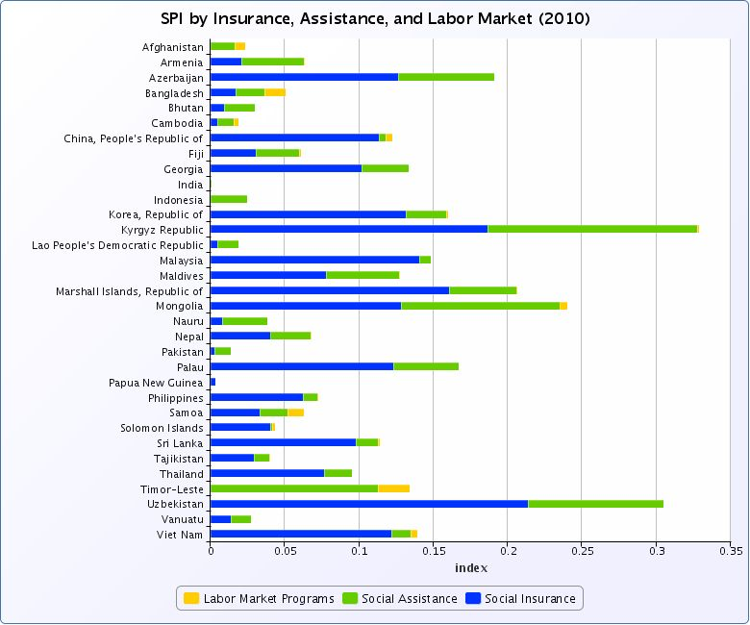

Source: ADB (2013)

* 1. **Government Commitments and Engagement in Social Protection for Children**

Social protection is an important policy tool for the realization of children’s rights and achieving equity and social justice, as stated in the CRC. In 1990, the GoN was one of the original signatories to the CRC. Building on the Universal Declaration of Human Rights, the CRC posits the right to social protection for children in its Article 26:

1. “States Parties shall recognize for every child the right to benefit from social security, including social insurance, and shall take the necessary measures to achieve the full realization of this right in accordance with their national law.
2. The benefits should, where appropriate, be granted, taking into account the resources and the circumstances of the child and persons having responsibility for the maintenance of the child, as well as any other consideration relevant to an application for benefits made by or on behalf of the child.”

CRC Article 27 corroborates this, arguing that

1. “States Parties recognize the right of every child to a standard of living adequate for the child's physical, mental, spiritual, moral and social development.
2. States Parties, in accordance with national conditions and within their means, shall take appropriate measures to assist parents and others responsible for the child to implement this right and shall in case of need provide material assistance and support programmes, particularly with regard to nutrition, clothing and housing.”

Other CRC articles that support the child right to Social Protection include: CRC 18, 19, 24, 28, and 32.

In Nepal’s Interim Constitution of 2007, Article 22 on the right of child commits that “every child shall have the right to get nurtured, basic health and social security.” Article 35 on state policies deepens this provision, promising that “The state shall pursue a policy of making special provisions of social security for the protection and welfare of single women, orphans, *children*, helpless, the aged, disabled, incapacitated persons and the … tribes.” (Interim Constitution of Nepal 2007, emphasis the authors).

In the Three Year Plan Approach Paper (2010/11 - 2012/13) the Government devoted a noteworthy portion of the plan to child protection (GoN 2010), while the Approach Paper to the Thirteenth Plan reconfirmed “…the four key rights of children, survival, protection, development and meaningful participation” (GoN 2013), under reference to the Ten-Year Children’s   National Action Plan. Particular concerns are with malnutrition, child labour, and children suffering from the aftermath of the civil conflict.

The GoN first introduced the Child Grant in fiscal year 2009/2010, in the context of an expansive set of social policies provided in that budget (for an overview see Upreti et al., 2012). As stated in the National Budget speech, the objective of this program was specifically to improve the nutrition of children (MoF 2009). In addition, from 2012 onwards MoFALD proscribed that 35 per cent of the annual block grant disbursed to village development committees are to be allocated to measures devoted to the empowerment of children (10 per cent), women (10 per cent) and disadvantaged groups(15 per cent) (GoN 2013; MoFALD 2012). These two social policy measures combine to signal a notable government commitment to child wellbeing and rights.

It will be helpful politically and administratively if the programme for an enhanced child grant is legally confirmed. This can ensure predictability and durability of the programme, increase transparency, and help to raise public awareness about the entitlement. In some countries, child grants and other social protection provisions are adopted as laws by parliament, in other countries, the Supreme Court issues a binding act. Another modality is to fix the programme in the fiscal budget act. As part of the the CG programme discussions in Nepal, it is proposed to include a reflection on the best modality for anchoring it in the legal and administrative processes.

It is important to underline here that social protection is a cross-sectorial issue for children. Social protection can play a key role in addressing some of the barriers that stand in the way of ensuring child rights and improving children’s wellbeing (UNICEF 2012). Social protection needs to be universalized for all, but from a child-rights commitment, social protection needs to be child-sensitive and therefore prioritize measures that directly or indirectly impact children, especially young children. This is because children face age-specific vulnerabilities that differ from those of adults (ILO 2014). These include the fact that child needs for nutrition and intellectual and emotional stimulation cannot be postponed, and if these rights and requirements are not met, the negative impact is irreversible. This fact is coupled with the observation that children tend to be over-represented among the poor.

The interests of children, therefore, require special attention during the process of designing or re-designing of the country’s social protection system. Moreover, by reaching out to those who are economically and socially excluded, social protection complements and underpins sector interventions in health and nutrition, education, water and sanitation, child protection including issues around children in conflict and child labour, HIV/AIDS and other areas. It can thus reinforce support to child rights, improve outcomes and increase equity for children, while at the same time supporting social justice and national cohesion (UNICEF 2012).

In Nepal, child-sensitive social protection is of particular relevance for inter-related reasons. Firstly, child poverty is a serious structural challenge undermining the rights of the child. A study published in 2010 showed that more than a third (35.6 per cent) of Nepal’s 12.6 million children live below the national poverty line, and almost 70 per cent are deprived of at least one of the seven basic human needs - shelter, sanitation, water, information, food, education and health (UNICEF, New Era and NPC 2010). In addition, under-five malnutrition is a persistent problem. It stands at 41 per cent at the national level, with even higher prevalence when disaggregated regionally, by wealth quintile, or by gender, caste and other factors of disadvantage (UNICEF, New Era and NPC 2010).

The above suggests that large segments of the population in Nepal are affected by poverty, inequality, and social exclusion, and that children are particularly vulnerable, experiencing high level of child poverty, malnutrition, and child labour. Thus it remains imperative to ensure and deliver the best possible social protection for children in Nepal as a means to address these issues, and to do this with urgency, effectively and with optimal use of fiscal and administrative resources.

1. **SocioEconomic back****DROP of SOCIAL Protection in nepal**
   1. **Overview**

This chapter presents an outlook of the demographic and socio-economic situation and dynamics in Nepal. Nepal has made considerable strides on human development, population dynamics, and economic growth. As a result, it is one of the countries whose HDI increased most steadily and significantly between 1980 and 2010, from 0.210 to 0.428 (UNDP 2010). This accomplishment needs to be duly acknowledged, especially since it was achieved against the backdrop of the country’s demanding geography, its difficult terrain, the conflict that lasted from 1996-2006, and myriad political and social challenges (Panday 2013). Further, the demographic status and dynamics present favorable condition – expansion of the working-age population relative to the general population. However, complex economic and social challenges remain to be tackled. Large segments of the population are affected by poverty and malnutrition, and children are particularly vulnerable. Several factors, including gender, ethnicity, region, disability, and lack of education, appear to have jointly resulted in inequities.

* 1. **Demographic Profile**

The most recent population census of 2011 estimated Nepal’s population at 26.5 million (CBS 2014). Approximately 17.1 per cent of inhabitants live in urban communities (CBS 2011). Over the past decade, Nepal’s population grew at an average annual rate of 1.47 per cent, which is similar to that of South Asia region (1.35 per cent), but is lower than that for Least Developed Countries (LDCs), estimated at 2.3 per cent (UN DESA 2013).

Table 1 Population Change in thousands, 1980 – 2010

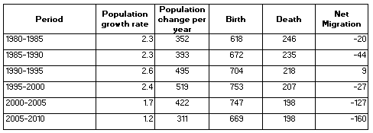

Source: Based on data from (UN DESA 2013)

The pattern of natural population growth (excluding migration) can be explained by two underlying factors: fertility rates and mortality rates. Since 1980, the Total Fertility Rate (TFR) decreased by almost half, from 5.65 children per woman in early 1980 to 2.99 children per woman in 2005-2010 (UN DESA 2013).

Figure 3 Total Fertility Rates, 1980-2010

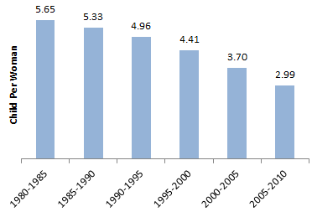

Source: Based on data from UN (2011b).

The second factor, the mortality rate, has shown significant improvement over the same period. The infant mortality rate declined from a rate of 124.4 infant deaths per 1,000 live births in the early 1980s to 44.7 per 1,000 births in 2005-2010. The crude death rate was estimated at 7.3 deaths per 1,000 live in 2005-2010, a decrease by more than half the rate of 16.1 deaths per 1000 in the early 1980s. Life expectancy at birth, therefore, increased steadily and reached 65.9 years in 2005–2010, compared to 49.4 years in 1980-1985 (UN DESA 2013).

As a result of declining fertility rates, improved mortality and increased life expectancy, the population structure has changed notably over the past few decades. The median age in Nepal increased from 19.2 in 1980 to 21.3 in 2010 (UN DESA 2013).

Figure 4 Population Pyramid, 1980-2050

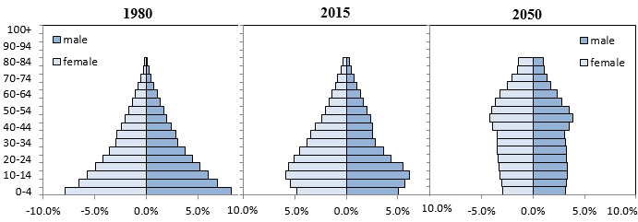

Source: Author’s calculation based on data from UN DESA (2013).

The broadening midchapter of Nepal’s population pyramid has two main potential consequences:

* First, the likelihood of steady and possibly increased population growth, despite the declining fertility rate. This phenomenon is known as the “demographic momentum,” which occurs due to the fact that more women are in their reproductive years. This might come into effect in the near future in Nepal, and translate into an increase in the pace of the population growth.
* Second: a situation where the working-age population expands at a higher rate than the general population. This is considered a favourable demographic development, which is widely referred to as “demographic window of opportunity”.

Similarly, the youth dependency ratio (the ratio of children under 15 years of age per working-age person) and the total dependency ratio (ratio of children under 15 years and elderly over 65 year-old per working-age person) have both decreased in Nepal.

The expansion of the working-age population, and the concomitant enlargement of the labour force, can present a favourable condition. However, it also constitutes a substantial challenge to the economy to create decent work and sufficient numbers of adequate jobs to absorb the incoming labour market participants. In Nepal, the challenge is expressed in the fact that youth unemployment (below 24 years) accounted for 43.3 per cent of the overall unemployed population in 2010/11 (Govenment of Nepal, 2009).

Figure 5 Population Growth Rates by Major Age Groups, per cent, 2000-2010

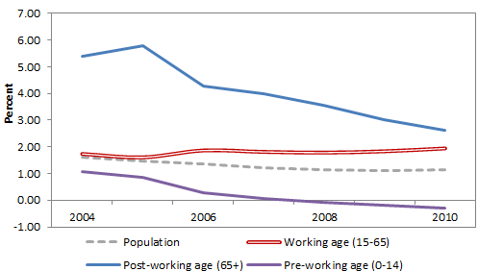

Source: Author’s calculation based on data from UN (2011a).

**2.3 Macroeconomic Profile**

The economy of Nepal presents a mixed picture. Over the past decade, GDP grew at an average annual rate of 4.23 per cent in real terms (IMF 2014). This is 3 percentage points above the population growth rate, resulting in an improvement in real GDP per capita. Nevertheless, Nepal’s economy suffers from a high inflation environment – CPI inflation is at 7.96 per cent and more since 2006, and currently 9.86 per cent (IMF 2014). Roughly 2.3 million outmigrants are registered. Many find employment under very difficult, sometimes life-threatening circumstances. Migrant remittances estimated to have reached about 30 per cent of GDP in 2013/14 (UN ESCAP. 2011b; Koehler 2014b; Khatiwada and Koehler 2014; IMF 2014).

Table 2: Main Economic Indicators, 2004-2013

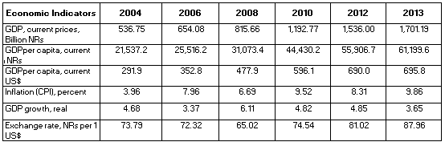

Source: Author’s calculation based on data from IMF database (2014)

**2.4 Poverty and Hunger Profile**

Despite of this modest economic growth rates, Nepal has achieved progress on income poverty reduction. For instance, the poverty rate reduced at 2.5 percentage points per year since 2004 (World Bank 2014a). Further, Nepal has made considerable strides on some of the non-income dimensions of human development.

Figure 6: Millennium Development Goals Indicators

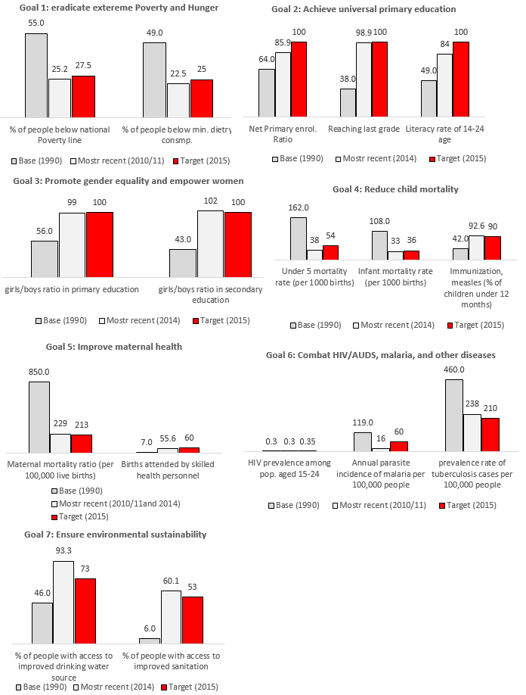

Source: Based on data from IMF (2014), MICS (2014)

However, progress on MDG-1a does not change the fact that 1,250,000 households (i.e. approximately 7 million Nepalis; which constitutes about 25 percent of the population), are still living below the poverty line in 2010/11 (GoN 2013) and 57 per cent of the population live under the USD $2 poverty line in 2010/11 (CBS, 2012). The poverty gap (the percentage deficit of per-capita expenditure from poverty line) was estimated at 5.44 in 2010/11 (CBS, 2012).

As the Government analysed in 2013: “Poverty alleviation is a formidable challenge, especially among women, Dalits, minorities, Madhesis, inhabitants of remote and backward regions including Karnali, persons with disabilities, and persons residing in hazard-prone urban areas, and in areas where all populations exhibit disproportionately high rates of poverty.” (GoN 2013). Women and girls, children affected by the longer-term effects of the conflict, children living with disability, and members of disadvantaged communities have higher poverty levels and significantly lower outcomes on nutrition, education and incomes (GoN 2010).

Poverty in Nepal moreover has an age dimension. Children and youth are more likely to experience poverty than older age groups. The incidence of poverty drastically increases as the number of children in the household increases (Figure 7). While the poverty rate for households without children was below 5 per cent, and the poverty rate of households with one to three children (18.3 per cent) was still below the national poverty rate (25.2 per cent), households with more than three children have a significantly higher poverty rate, at almost double the national poverty rate (CBS, 2012). Over a third of Nepal’s 12.6 million children live below the national poverty line (CBS, 2012).

Figure 7: Household Poverty Rates by Number of Children in the Household, 2010/11

Source: Based on NLSS III (2010-2011)

Regionally, the Far-Western region of the country has poverty rates of 46 per cent, more than double the rates seen in the Central and Eastern regions (GoN, New Era and ICF International, 2012).

In many households, income poverty is coupled with malnutrition (Table 3). According to the Nepal Demographic and Health Survey 2011 (NDHS), 41 per cent of children under 5 years of age are stunted, 11 per cent are wasted and 29 per cent are underweight. The prevalence of stunting in particular is very high in the Mid-Western Mountain Districts (59.5 per cent), and wasting and underweight are both also higher than the national average (13.2 per cent and 42.0 per cent respectively) (NPC 2011).

Table 3: Nutritional Status by Wealth Group

|  |  |  |  |
| --- | --- | --- | --- |
| Wealth Quintiles | Stunted | Wasted | Underweight |
| Lowest | 56 | 12.5 | 40.3 |
| Second | 45.7 | 10.7 | 31.6 |
| Middle | 34.5 | 12.8 | 28.8 |
| Fourth | 30.5 | 8.8 | 22.9 |
| Highest | 25.8 | 7.4 | 10.0 |

Source: NDHS (2011)

In the context of Nepal, there are many causes of income poverty and malnutrition (Panday 2013; UNICEF, New Era and NPC 2010), including:

* Landlessness and low agricultural productivity;
* Lack of decent work;
* Environmental degradation;
* Lack of education; and
* Long-term after-effects of the conflict.

Most Nepalis work in the informal economy with unstable income and no social protection. 74 per cent of landholdings are under 1 ha (FAO 2010). The degradation of the environment is creating additional stress and displacement. These forms of disadvantage are coupled with low levels of education beyond basic literacy, especially for women (UNICEF, New Era and NPC 2010; Koehler 2014a). These structural issues are acknowledged as key challenges in the current Development Plan 2013/14-2015/16 (GoN 2013).

Clearly, no social protection programme, no matter how encompassing and generous, can eradicate poverty, or deeply-engrained processes of social exclusion, or overcome the lack of decent work , or the lack of productive assets such as land. But social protection measures can tackle the adverse impacts of such socio-economic factors and help individuals and households to avert, or cope with, the worst outcomes. They can decrease vulnerability and risk, and supplement incomes so that families and households can at least ensure minimum food and income security. Further such policies could potentially have longer term impacts on intergenerational transmission of poverty as they could address some of the fundamental drivers of poverty. This is especially the case with social protection measures designed to tackle issues related to child poverty.

The facts presented in this chapter suggests that large segments of the population in Nepal are affected by poverty, inequality, and social exclusion, and that children are particularly vulnerable, experiencing high level of child poverty, malnutrition, and child labour. These various inequities often intersect. Therefore, a universal approach is the best strategy for any social policy, including for social protection interventions. It would be politically difficult and could even become divisive to single out groups of the disadvantaged for a particular social protection support measure. For example, younger age eligibility for the Old Age Allowance among the Dalits resulted in confusion and perception of unfairness among members of Dalit community and other castes (KC et al., 2014).Also, a selective or targeted approach is technically complex, and more costly to deliver. A universal approach on the other hand can have an effect of political healing and nation building, beyond its sheer advantage as delivering a basic social right to all citizens, offering basic income security, and in ideal circumstances also fostering economic growth.

1. **The Child grant Program in Nepal: CURRENT Status and INITIAL outcomes**
   1. **Overview**

The Child Grant was first introduced in fiscal year 2009/2010 for the objective of improving the nutrition of children (MoF, 2009). Eligible children, up to two per family in the current approach, are entitled to a benefit of NRs 200 per month which would sum up as 2400 rupees per child per year, with a maximum of 4800 rupees per family where there are 2 under-5 children, to be paid in trimestral instalments. Since inception of the program, none of the design elements have been revised and the benefit amount has not been raised; there had been no indexing to the national CPI, nor pegging to local food prices. [4]

The Child Grant is geographically targeted to under 5 children in the five Karnali districts[5], which are the poorest in the country, and to under 5 children from poor Dalit families across the country. The Child Grant was thus targeted geographically – to the poorest region, and by caste cum poverty in the remainder of the country.

In 2009, a decision for geographic and categorical targeting was made to reach the most vulnerable children with a priority; given that the fiscal budget resources are limited. The highest rate of malnutrition is observed in five Karnali districts (underweight 42 per cent against 29 per cent national average, stunting 60 per cent against 41per cent and wasting 13 per cent against 11per cent) and also among Dalit families (underweight 35 per cent against 29 per cent, stunting 47 per cent against 41 per cent and wasting 18 per cent against 11 per cent) (GoN, New Era and ICF International, 2012). However, the government at that time indicated its intention of scaling up the program nationally to reach universal coverage of all children under 5 [6] (Khatiwada and Koehler 2014). In fact, GoN has announced to expand the Child Grant in Bhanjang and Bajura districts through Budget speech 2012/ 2013, though the implementation is yet to start (MoF 2012).

Although the design does not have an explicit conditionality, the implementation process has facilitated birth registration which is obviously a prerequisite to claiming the grant (discussed see below). Further, complementary outreach programs were put in place which encouraged parents to utilize the cash grant for providing nutritious food to their children.

* 1. **Extent of Coverage**

A survey conducted in 2012/3 showed that the Child Grant covered a total of 551,916 children in Nepal (90,349 in Karnali and the others are from Dalit background across the country), which is slightly more than one out of five children under five years-old (Adhikari et al., 2014). Compared to early-phase outcomes of child benefits programs in other countries, and considering Nepal’s economic challenges as an LDC, this can be considered a remarkable achievement, in terms of the absolute number and share of child population reached.

In 2013, the Government of Nepal (GoN), UNICEF and Valley and Research Group (VaRG) conducted a cross-sectional survey in Karnali zone to assess effectiveness, coverage, compliance and potential impacts of the Child Grant. According to findings from this survey, 78 per cent of eligible families had received the Child Grant in the previous year, and 83 per cent reported having ever received the cash grant. However, the survey revealed an age bias. Coverage among children age less than 12 months was only 57 per cent while at the age of 36 months, coverage was found to be to 95 per cent. Delays in birth registration seemed to have contributed to this difference (GoN, UNICEF, and VaRG Forthcoming).

* 1. **Implementation Mechanism**

The Child Grant uses the same registration and delivery mechanism as Nepal’s other cash transfer programs, such as the social pension, transfers to people living with disability, the education grants and others. At the central government level, MoFALD is responsible for implementation. Registration and delivery of the grant are managed by the Village Development Committees (VDCs) with supervision from the District Development Committees (DDCs) (IDS 2014).[7]

A complementary programme was initiated in conjunction with the Child Grant in the five districts in Karnali zone. Its purpose was to inform and raise awareness of the Child Grant and Infant and Young Children Feeding (IYCF) practices through a broad public out-reach campaign.[8] A birth registration campaign facilitated mobilizing eligible recipients, VDC officers, health volunteers and others to provide easier access to birth registration at ward level (UNICEF 2010).

* 1. **Challenges and Constraints**

3.4.1 Limited Benefit Amount

The main shortcoming of the Child Grant is the low benefit level (Adhikari et al., 2014). At 200 NRs per child per month, the benefit is too low to achieve substantial outcomes. The amount represents only 3.46 per cent of GDP per capita and only about 13 per cent of the poverty line (Adhikari et al., 2014). With this NRs 200, one can merely buy for example 2-3 kilograms of rice or 8-10 eggs in the Karnali districts where price levels are higher than in the other regions because of transport costs (GoN, UNICEF, and VaRG Forthcoming). There has been no indexation of the benefit since the program started, despite the considerable level of inflation. This undermines the impact of the Child Grant on nutrition and, more generally, on the income of families with children.

A multi-country review of social cash transfer programmes confirms the critical importance of the size of the benefit (Fiszbein, Schady, & Ferreira, 2009). For instance, it is reported that the Programa de Asignación Familiar (PRAF) in Honduras did not have any impact on nutrition due to the relatively small amount of transfer (Fiszbein, Schady, & Ferreira, 2009).

3.4.2 Transfer Amount

According to the same study by GoN, UNICEF and VaRG (forthcoming), it was revealed that the amount of CG received varied across households even among recipients (Figure 8). While the formal rule states the annual transfer to be NRs 2400 per child, more than half of the beneficiaries in the sample received less than or equal to NRs 1,000 and the average amount received among the beneficiaries was NRs 1,045 per child (with standard deviation NRs 579). While the underlying causes of payments that are lower than stated in official rules are not yet fully understood, the previous studies point out to implementation issues on the supply side, such as delay in delivery, irregularities in the application process and infrequent payments (Adhikari et. al., 2014; GoN, UNICEF and VaRG forthcoming)

Figure 8: Actual Amount of Child Grant Received per Child, Annually, 2013



Source: Author’s calculation based on GoN, UNICEF and VaRG (forthcoming)

3.4.3 Frequency and Modality of Payments

Timely payment is another major concern. The same study by GoN, UNICEF and VaRG found that only about 2 per cent of families received funds regularly, (i.e. three times a year) as per the rule. The vast majority (79 per cent) received Child Grant funds only once a year. Some 33 per cent of households reported that it had been more than 10 months since they last received the Child Grant, while for 38 per cent of the households, it had been between 7–9 months. 54 per cent mothers reported that it was not clear when they would be receiving the next instalment. Understaffing of VDCs, lack of transport and resources, and the difficult climate and terrain made it difficult in some areas of the country to disburse the benefit on time. Security – in light of moving large sums of cash – can also be an issue (IDS 2014). Evidence from many countries suggests that timeliness and regularity in the Child Grant is required in order for it to have an effective and sustained impact on children’s nutritional status (Delany et al., 2008).

3.4.4 Beneficiary Identification

The MOFALD uses a decentralized structure, such that VDCs and DDCs are responsible for creating the lists of eligible beneficiaries, and for delivering social transfers (IDS 2014). For the Child Grant, beneficiaries are identified at the VDC level, where the list of beneficiaries is approved and sent to DDC. The DDC compiles the list from each VDC and sends the list to the Ministry. Birth registration is the major instrument to identify Child Grant beneficiaries. In addition, communication campaign and social mobilization were conducted to identify the beneficiaries (UNICEF 2010). At early stage when the Child Grant was introduced, identifying beneficiaries was difficult in the absence of legal document to prove age, which led to high inclusion error. However this problem is gradually minimized as the birth registration of children under the age of 5 is now 90 per cent in the Karnali districts (UNICEF and NATG 2012).

Regarding the targeting of ‘poor’ Dalit families in the districts other than Karnali Zone, identification of beneficiaries faced difficult challenges. Since the procedure to identify poor families was fairly complicated, field observations and interviews with VDC secretaries and local development officers in Darchula and Kavre during 2012-2013 indicated that VDCs were providing the Child Grant to all children from Dalit Families, instead of following the selection criteria[9]. As reported by the VDC secretaries, the field observation suggests that poverty targeting is not possible due to lack of administrative capacity at the VDC level to identify beneficiaries based on poverty criteria.

1. **Impact of the child grant**

This chapter provides an assessment of potential impacts that result from scaling up the Child Grant based on evidence from Nepal and other international experience. First, the significant increase in birth registration is reviewed. Second, cross-country evidence of cash transfer on nutrition and health are presented. Further, linkages between the Child Grant and with economic growth are discussed.

* 1. **Impact on Birth Registration**

Registering a child’s birth is a critical first step towards realising child rights, because it facilitates the child’s citizenship, establishes rights to primary health services, and in the life course assures correct timing for school enrolment, and establishing the legal working age and in due course, social pension entitlements (UNICEF 2013). In a soft sense, it establishes a sense of personal and national identity, and it can be a preventive factor safeguarding the child’s survival and flourishing. Thus it can contribute to child protection and even to lifelong protection. A comprehensive and functioning system of vital registration is also a prerequisite for implementing a social protection floor approach to social protection.

The NDHS survey showed that only 42.3 per cent of children under the age of 5 in Nepal had their birth registered (GoN, New Era and ICF International, 2012). The Child Grant has yielded an important secondary effect of increasing birth registration (GoN, UNICEF and VaRG, forthcoming). Birth registration for children below 5 years on average increased to 90 per cent in the Karnali districts, which is more than double the 2010 rate of 42 per cent for the same districts (UNICEF and NTAG, 2012). The figure below shows high birth registration rate in Karnali in comparison to national average as well as other countries in South Asia.

Figure 9 Birth Registration Rate in South Asia

Source: Based on MICS (2014), DHS (2011) and UNICEF Global Statistics (2014)

Effort is still needed to increase the coverage of the Child Grant especially among children below 12 months of age, which is significantly lower. For example, the birth registration rate among infants younger than 12 months were 63.2% compared to 98.4% of children aged 48-59 months (GoN, UNICEF & VaRG, Forthcoming).

* 1. **Impact on non-income dimensions – international experience[10]**

Simulating the impact of the proposed system on non-income dimensions is challenging and beyond the scope of this study. An econometric analysis of child under-nutrition and per capita Child Grant received indicates that receiving Child Grant was associated with reduction in moderate level of underweight and severe wasting, but was not associated with stunting, severe underweight or moderate wasting because of the limited benefit amount (Okubo 2014). On the other hand, evidence from different countries, shows that progress to achieve the MDGs can be accelerated when cash transfer programs and approaches are used to complement supply side interventions by increasing demand to services. Below is a list of selected country examples:

Nutrition:

* Nicaragua: The Red de Protección cash transfer programme reduced stunting among children 6-59 months by 5.3 percentage points, with stronger impacts among poorer families. Moreover, during the coffee price shock, beneficiaries of this program were able to maintain and modestly increase per capita food consumption, while in other comparable households per capita consumption declined sharply.
* South Africa: children in households receiving a pension have on average 5cm greater growth than those in households without a pension – this is the equivalent of approximately half a year’s growth for Black and Coloured children.
* Mexico, Malawi, and Colombia: Social Protection programmes demonstrate reductions in stunting.

Health

* Mexico: Oportunidades led to a 17 per cent decline in rural infant mortality (8 percentage points on average). It also led to a reduction of maternal mortality by 11% among women participating and impacts were strongest in more marginalized communities.
* Bolivia: between 1993 and 1997, infant mortality rates among participating households in Bolivia’s Social Fund declined from 61 to 31 per 1000. For non-participating comparable households, infant mortality rates did actually increase from 60 to 67 per 1000. Under 5 mortality rates fell over the same period from 94 to 55 per 1000 in participating households, but rose from 93 to 108 per 1000 in comparable non-participating households.
* Jamaica: In all cash transfer programs for which there is data, with the exception of the PATH programme in Jamaica, incidence of illness has decreased among children, particularly younger children.

**4.3 Impact on Economic Growth**

A predictable and reliable social cash transfer program can play a role as an economic stimulus to foster economic growth (Mathers and Slater, 2014). This is due to several factors. Firstly the increased income can lead to more consumption, and thus contribute to human capacity building, thereby in the longer run notionally having a favourable impact on productivity. Secondly, if the transfers are financed from progressive taxation, there can be a Keynesian-type multiplier effect, given the fact that lower-income households have a higher marginal propensity to consume. The additional incomes poor households receive (from the program or other sources) are spent to a large degree on basic necessities, whereas richer households’ incremental reductions of their incomes (resulting from financing the benefit via their taxes) are not expected to reduce their consumption by the full amount. This gives a rise to a multiplier effect: the increased consumption resulted from the benefit leads to increased incomes of local producers and service providers, which further leads to increased consumption, etc. In other words, the initial amount spent on the proposed system of benefits may cause a change in aggregate output that is a multiple of the initial change.

For instance, an increase of 1 per cent of GDP in Bolsa Familia program in Brazil was estimated to result in a positive change of 1.44 per cent in GDP (ILO, 2011). Social transfer programs comprised a significant portion of the early fiscal stimulus packages introduced in high- and lower income countries alike following the 2008 financial crisis. It was estimated that on average about 25 per cent of fiscal stimulus spending was invested in social protection in both middle and higher income countries (UNICEF 2010).

1. **INTRODUCING IMPROVED CHILD GRANTS OPTIONS**

While these findings from available reviews and evaluations suggest that Child Grant has reached many vulnerable children from Karnali and Dalit households, it is necessary and timely to review and reflect on the coverage, design issues, and the grant’s overall effectiveness for better impact. A range of options is conceivable to enhance the program. All of them would entail a scaling-up, firstly in terms of moving to universal coverage over time, and secondly in terms of benefit amounts and improvements in the delivery.

* 1. **Scaling Up Scenarios**

The first policy objective would be in terms of extending the coverage of the program, to reach all children of a given age level. Conceptually, the argument for a universal Child Grant stems from the CRC, as well as from the commitments made in the Interim Constitution and other government policy statements. In light of the intersecting inequalities facing children, the case for universalization also derives from the difficulty to single out particularly disadvantaged communities, or to limit the grant only to the lowest wealth quintiles, as the majority of the population lives close to the $2 poverty line. Such distinctions can become politically divisive, and technically complex. An approach that covers all citizens can have a unifying effect. A universal Child Grant can also help overcome the somewhat fragmented nature of social protection measures currently in place, and help achieve the goal of minimum social protection for all in the context of the National Framework for Social Protection (NSCSPF 2012).

In addition, enhancing and scaling up needs to be considered in terms of providing an increased benefit level. This is in response to the finding that the current benefit is too low to make a dent in household income and an analysis presented in Chapter 5 that finds further nutritional impacts when the benefit amount is raised (Adhikari et al., 2014; Okubo 2014).

The period of greatest vulnerability for the survival and development of the child is from pre-birth to 5 years, and within that the period as a foetus and the first two years (UNICEF 2011b). One consideration in the scaling up process therefore relates to the observation that an impact on child malnutrition in particular would require an intervention to set in before the infant’s birth. This leads to the proposal to start the child benefit during a mother’s pregnancy. The purpose would be to help ensure that she has resources for her own better nutrition, to cover pregnancy-related health or social expenditures, or to be able to afford some rest during her pregnancy, post-partum and during breastfeeding by outsourcing some of her work burden. In other words, the scaling up involves an extension forward of the eligibility time line. The fact that the first two years are the most sensitive in turn leads to one suggestion proposing a grant for the first 1000 days (i.e. between the start of a woman’s pregnancy and her child’s second birthday).

Accordingly, a set of scenarios for enhancing and scaling-up the Child Grant are presented below. All of them have a premise of extending the coverage to all children in Nepal. They propose an earlier set-in, different age ceilings, and a range of benefit levels.

The range of alternative age levels and benefit amounts may serve to provide policy makers with an estimate of respective costs and impacts. These can then be assessed in line with societal aspirations on social outcomes, and government commitments to child rights and well-being, and weighed against the background of Nepal’s current and potential fiscal space.

Table 4: Child Grant Scaling Up Scenarios

|  |  |  |  |  |
| --- | --- | --- | --- | --- |
|  | **Scenario** | **Coverage** | **Benefit amount** | **Eligibility** |
|  | **Pregnancy Benefit** |  |  |  |
| 1. | Pregnancy Benefit A | National | NRs 500 a month | Pregnant women, last 5 months of pregnancy |
| 2. | Pregnancy Benefit B | National | NRs 750 a month | Pregnant women, last 5 months of pregnancy |
| 3. | Pregnancy Benefit C | National | NRs 1000 a month | Pregnant women, last 5 months of pregnancy |
|  | **U-2 Child Grant** |  |  |  |
| 4. | Under 2 years A | National | NRs 500 a month | All children under 2 years of age |
| 5. | Under 2 years B | National | NRs 750 a month | All children under 2 years of age |
| 6. | Under 2 years C | National | NRs 1000 a month | All children under 2 years of age |
|  | **U-5 Child Grant** |  |  |  |
| 7. | Under 5 years A | National | NRs 200 a month | All children under 5 years of age |
| 8. | Under 5 years B | National | NRs 300 a month | All children under 5 years of age |
| 9. | Under 5 years C | National | NRs 500 a month | All children under 5 years of age |

* 1. **Conditionality and Targeting**
     1. Conditionality and linkages

There is a long-standing discussion, in Nepal and globally, on the question of coupling cash transfers to behaviours, and there are mixed findings on the impact and outcomes of such conditional versus unconditional cash transfers.[11] Although there is evidence to suggest that either form can have positive outcomes, the particular role and attribution of these outcomes to conditionality remains an open debate, and is contextual. A separate exercise is needed to make sure that whatever conditionalities were to be imposed, they do not run into supply side constraints.[12] If a choice is made to introduce conditionalities, it is also important to ensure that the required reporting on meeting the conditions does not impose an additional burden on women and families that reporting processes are transparent, and that responses to perceived non-compliance are supportive rather than punitive.

* + 1. Targeting

The scenarios listed above are all based on a premise of universal coverage for respective age category. However, it is assumed that a form of targeting is implicitly built in. First, there is a self-targeting component, where the low level of the benefit amounts, coupled with administrative burden to register and receive the benefit, are likely to result in less than 100 per cent take up, as higher income groups may not claim the benefit. Secondly, as an alternative to immediate universalization, categorical and geographical targeting, as used in the current Child Grant, could be retained for a further period of time, albeit with the longer-term vision of and commitment to universalizing whichever type of enhanced Child Grant is selected, as resources become available. This strategy is consistent with the draft of National Framework for Social Protection, which states: “given capacity constraints in administering a range of safety net programs, the choice of geographical and categorical targeting in Nepal seems reasonable. Such targeting mechanisms are less resource intensive and less taxing both in terms of time and administrative needs. In addition, geographical and categorical targeting have been tested and therefore, are more acceptable politically and less prone to social tensions than other forms of targeting”. (NSCSPF 2012)

* + 1. Linkages to existing cash transfer programs

As is well recognized, Nepal features a very broad range of social protection measures as discussed in Chapter 1 and Annex A. It is crucial for a number of reasons that the different forms of social protection, and notably different transfers comprising social assistance, cohere as a system. This would serve to achieve consolidated and stronger impact, including for vulnerable households with children, and make it easier for households to oversee all their entitlements,[13] and to use them well. For the government, it would rationalize the management of the programs, in terms of beneficiary registration, and benefit disbursement and tracking. Furthermore, a better coherence among programs could improve fiscal resource use. For example, the maternity incentive scheme, which provides cash transfer to pregnant mothers and health facilities conditional upon prenatal check-ups and institutional delivery, is also recommended to be linked to the Cash Grant, especially if the revised coverage extends to pregnant mothers.

The GoN is currently exploring the introduction of a social protection floor (SPF) corresponding to Recommendation R202 of the ILO (2012). This framework in the longer run aims at a convergence of social security and social assistance. As mentioned earlier, the components of the SPF are universal health coverage, income security in childhood and in old age, and income security during working age for those unable to earn sufficient income. The enhanced Child Grant would be a central building block in this framework, and in recognition of the centrality of child rights, it could have priority. In combination with the social pension, which is already well-established, and universal health coverage, which was introduced as a right in 2009, the government could then in a next step proceed to address social protection for people of working age.

* 1. **Methodology of the Costing of the Proposed System**

In this study, the projection exercise is divided into two parts: First, projection of the underlying factors (demographic and macroeconomic). Second, under a set of specified assumptions on the benefit parameters discussed earlier (eligibility conditions, coverage, benefit level etc.), beneficiaries, benefit level, and overall costs are projected until 2020. In the next chapter, the cost structure will be integrated within the overall fiscal envelop of the country.

The linkages and dependency structure of the projection parts are illustrated in the following diagram.

Figure 10: Projection Model Components and Dependency Structure

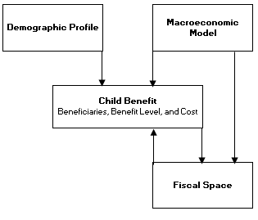

* 1. **Projection Assumptions and Results**
     1. Projection of the Demographic and Macroeconomic Profile:

For the demographic projection, the study uses the medium-variant population projection made available by the United Nations Department of Economic and Social Affairs, Population Division (UN DESA 2013). The data set is disaggregated by sex and single-year age. The following table summarizes the population projection’s main characteristics relevant to the study.

Table 5: Population Projection (Medium Variant) Main Characteristics, 2014 - 2020

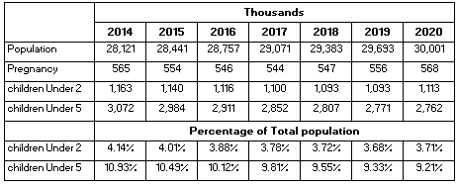

Source: Author’s calculation based on data from UN DESA(2013).

Figure 11: Population Growth Rates by Major Age Groups, 2010-2030

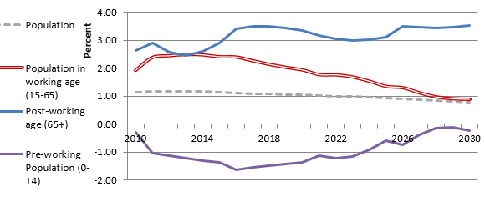Source: Author’s calculation based on data from UN DESA (2013)

For the macroeconomic model, the study uses the IMF’s latest[14] medium-term forecast for real GDP growth rate and inflation rate, which covers until 2019. From 2019 to 2020, the rates are fixed at the rate of 2019. GDP in current prices and per capita GDP are calculated for the projection period.

Figure 12: Macroeconomic Model’s Assumptions- GDP Growth Rate and CPI Rate

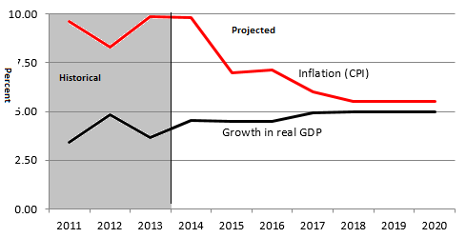

Source: Based on data from IMF (2014).

* + 1. Projection of Beneficiary Numbers

For the set of scenarios stated earlier, take up rate is assumed at 80 per cent of the eligible population, based on the latest statistics of the take up rate in Karnali zone (GoN, UNICEF, and VaRG forthcoming). The assumption is that despite a universal benefit, higher income-quintile families will not claim their benefit.

Applying an 80 per cent coverage rate into the corresponding age groups gives the program beneficiaries for the three groups that make up the scaling up scenarios.

Figure 13: Beneficiaries in Thousands, 2014-2020

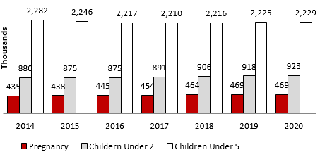

Source: Own Calculation based on data from UN DESA (2013)

* + 1. Projection of Benefit Level and Overall Cost

As stated under the scaling up scenarios, different benefit amounts are proposed (i.e. NRs 200, 300, 500, 750, and 1000 NRs). All children in the household under the age ceiling are entitled, as is the mother for each of her pregnancies; the pregnancy benefit is payable during the last 9 months of pregnancy.

The benefit amounts are indexed with inflation. While this indexation method maintains the benefit amount value in real terms, it does not allow for an increase in the benefit amount in real terms, in line with any overall improvements in the economic condition and standards of living. At later stage, a periodic review of the real value of the benefit can be introduced to ensure coherence and relevance.

Table 6: Benefit Amount in Current Local Currency and as a percentage of Food poverty line (2014) and Per Capita GDP, 2014-2020

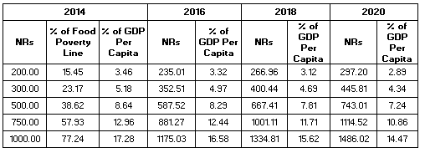

Source: Authors’ calculation based on data from IMF (2014) and CBS (2012)

The total benefit amount spent under each scenario is calculated as the product of the beneficiaries and the benefit amount for each year in the projection period for each scenario. Administrative cost is assumed conservatively at 20 per cent of the benefit amount.

Table 7: Total Expenditure of all Scenarios in Billion NRs, as a percentage of GDP, and as a percentage of Government Expenditure, 2014-2020

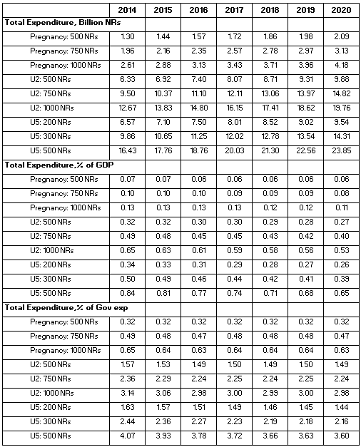

Source: Authors’ calculation based on IMF (2014) and UN (2011a)

Figure 14: Total Expenditure of all Scenarios in Billion NRs and as a percentage of GDP (right axes). 2014

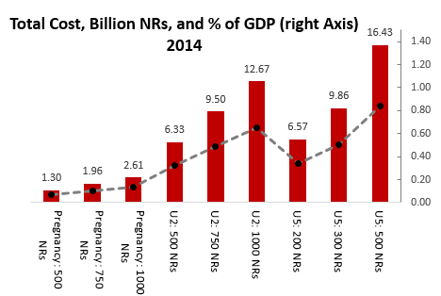

Figure 15: Total Expenditure of all Scenarios in Billion NRs and as a percentage of GDP (right axes), 2020

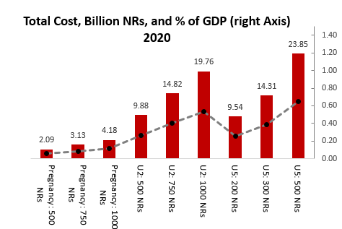

The costing exercise shows several things. Firstly, as birth rates slow down and GDP increases, the annual expenditures as a share of GDP decrease continuously by 2020 for any of the options. For example, a universal birth to five grant of 500 NRs would cost far less than 1 per cent of GDP; it would be an estimated 0.84 per cent of GDP in 2014, and decline to 0.65 per cent of GDP by 2020. The costs for any of the grant options are of course large when calculated as a share of the fiscal budget, but is expected to decrease over time. A universal birth to five year grant of NRs 500 would be 4 per cent of the fiscal budget at introduction, and decrease to 3.6 per cent by 2020.

Another possible form of Child Grant begins before the child is born, covering for example the first 1000 days from the onset of pregnancy until age two. Its calculated costs would range from 0.39 (NRs 500) to 0.78 per cent (NRs 1000) of GDP in 2014, depending on benefit amounts chosen. If well implemented, the grant can focus on the most vulnerable phase in an infant’s life, and provide some small economic support to the mother during the latter part of her pregnancy and during the breast-feeding period. This approach could moreover try to offer more meaningful benefit amounts, but even then it would cost less than the current under-5 Child Grant due to smaller number of beneficiaries.

1. **ASSESSING THE Fiscal Space[15]**

A discussion of social protection measures financed from the fiscal budget needs to recognize the importance of the national budget. Government expenditures on public goods and services (education, health, water and sanitation, and social protection among other sectors) and on economic infrastructure are a precondition to achieving and sustaining achievements in human development goals. Furthermore, decisions regarding financing the budget have equity consequences. This chapter discusses Nepal’s fiscal space.

Fiscal space is defined as “the room in the government’s budget that allows it to provide resources for a desired purpose without jeopardising the sustainability of its financial position or the stability of the economy” (Heller, 2005). In general, there are several options available for decision makers to create fiscal space to fund economic and social development. Main options include (Roy, Heuty, & Letouze, 2009):

* Increasing revenues via improved taxation;
* Reprioritization of expenditures;
* Adopting a more accommodating macroeconomic framework (e.g. tolerance to some inflation, larger fiscal deficit, government borrowing);
* Using fiscal and central bank foreign exchange reserves;
* Increased official development assistance and transfers.

Before investigating each option, the national budget including the overall accumulated debt for the past two years as well as the 2014/5 budget is presented below, in current currency and as a percent of GDP. Information on the budget will be referred to frequently in the coming sections.

Table 8: National Budget in Billion Nepali Rupees (NRs.) and as a Percent of GDP, 2012/13-2014/15[16]

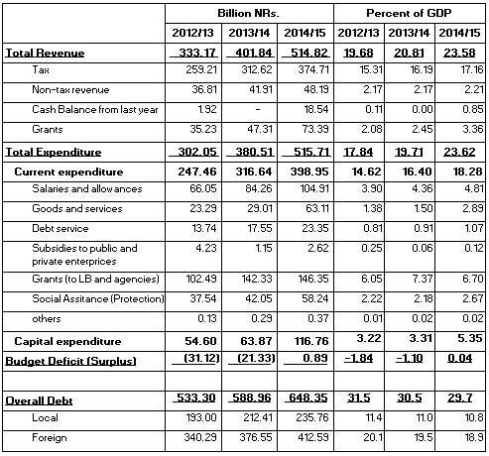

Source: Based on data from MoF (2014) and IMF (2014).

**6.1 Improved Taxation**

Contemplating the revenue side of fiscal space, it is noted that revenue performance has been strong in Nepal over the past couple of years. The national budget for fiscal year 2013/14 projected total revenue to stand at NRs. 374.71 billion, which is 23.58 per cent of GDP for the same year. This is an increase by 2.77 percentage point of GDP over one year (Ministry of Finance, 2014). As a result, Nepal has a tax to GDP ratio of 17 per cent and revenues (excluding grants) to GDP ratio of 20 per cent in 2014/5 – which is a comparatively high rate for a low income country and outpaces the regional average (Table 9). Nevertheless, total tax rate expressed as a percentage of commercial profits compares favorably with countries at the same economic level and regional comparators, signaling potential space for improved taxation.

Table 9: Budget Revenues (Tax and non-Tax) as a per cent of GDP for Nepal and Comparator Regions

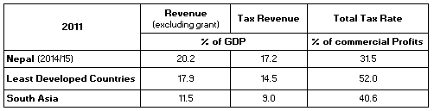

Source: Based on data from World Bank (2014b) and MoF (2014)

The share of taxes on goods and services (mostly VAT and excises) in the total tax collection is high and amounts for more than half of the total tax revenue in budget 2014/15 (Ministry of Finance, 2014). VAT is generally a regressive tax[17] as it taxes consumer goods and services that make up a higher share of total household expenditures in low income households compared with higher income groups. This highlights the need for tax incidence assessment and possible tax reforms to offset the potential welfare loss for low income groups.

Figure 16: Different Taxes as a per cent of total Taxes, Budget Fiscal Year 2014/5

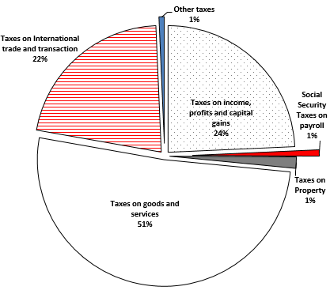

Source: Based on data from Ministry of Finance (2014).

The more progressive direct tax items on property, income, profits, and capital gain constitute about a quarter of the total tax collection. While the direct taxes can potentially grow further benefiting from the tax rate differentials highlighted in table 9, their growth rate was at a lower rate than that of the more regressive tax items; indicating a potential increase in the overall regressivity of the tax system in Nepal.

Figure 17: Different Taxes and Inflation Growth Rates (Base year is 100 in 2012/13)

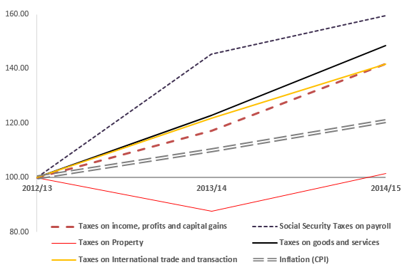

Source: Based on data from Ministry of Finance (2014).

Revenues are projected to further grow, though at decreasing rate, and stabilize in the medium term at between 21-22 per cent of GDP according to the IMF (IMF, 2014).

**6.2. Reprioritization of expenditures**

Turning to the expenditure side, the trend has been a significant annual increase in expenditures, which have however been in tune with the increases in revenues (see Table 8 above). The national budget for fiscal year 2014/15 projected a large public spending increase of 27.5 per cent in real terms over the previous year’s budget. The bulk of the increase in the budget is in the capital budget, which is projected to increase from 3.31 per cent of GDP in fiscal year 2013/14 to 5.35 per cent of GDP in fiscal year 2014/15 (Ministry of Finance, 2014).

Figure 18: Public Spending as a per cent of Total Spending, Economic Classification, 2014/15

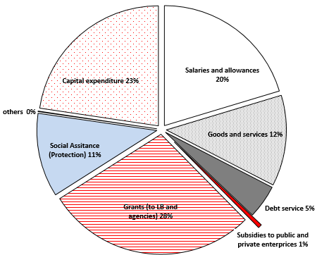

Source: Based on data from Ministry of Finance (2014).

In terms of a functional classification, the budget projects an uneven increase in public spending across the different sectors. Allocation to the education budget is projected to increase by less than half of one per cent in real terms. That is a negative growth in per capita spending as shown in below figure. On the other hand, allocation to health is slightly higher than the average increase in the overall public spending (Ministry of Finance, 2014).

Figure 19: Nominal, Real-Term, and Per Capita Growth Rates in National Budget between Fiscal Year 2013/14 and 2014/15.

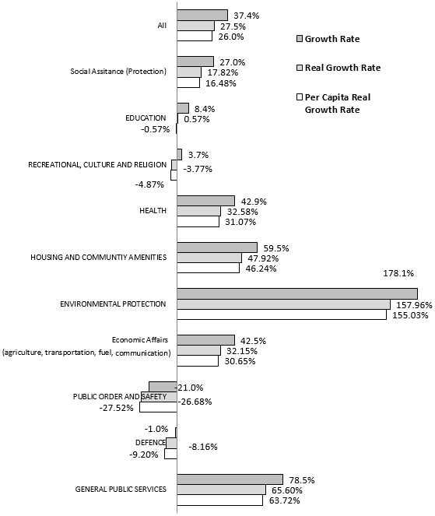

Source: Based on data from Ministry of Finance (2014).

Education’s share of the overall budget for fiscal year 2014/15 stands at 13.9 per cent of the overall public spending (Ministry of Finance, 2014), which represents 3.9 per cent of GDP for the same year. This is far below recommended spending of 20 per cent of overall spending recommended by the Education for All Initiative 2000. As for the health sector, there is a very low government allocation, projected to constitute only 6.1 per cent of the overall budget for fiscal year 2014/15 (Ministry of Finance, 2014), which represents only 1.7 per cent of GDP for the same year. The high rate of increase projected is particularly important.

Figure 20: Public Spending Functional Classification as A per cent of Overall Spending and as a per cent of GDP, Fiscal Year 2014/15

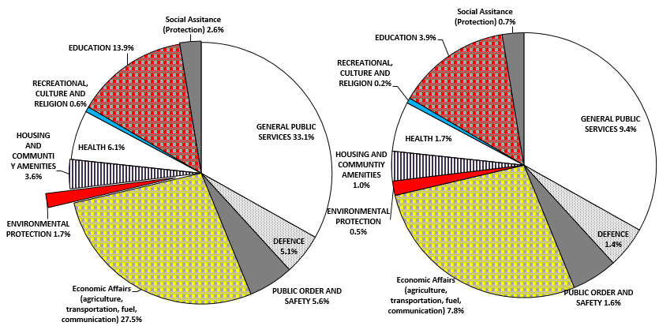

Source: Based on data from Ministry of Finance (2014).

Other international sources estimate allocation to health at a higher level. The WHO puts it at about 10.4 per cent of the overall budget for 2012 (WHO, 2014). Using the WHO data, Nepal seems to compare favourably with regional comparator countries – in effort, or percentage – but is very low in per capita terms, reflecting the low level of per capita income.

Figure 21: Expenditure on Health as a per cent of GDP and in Per Capita USD, 2009**[18]**

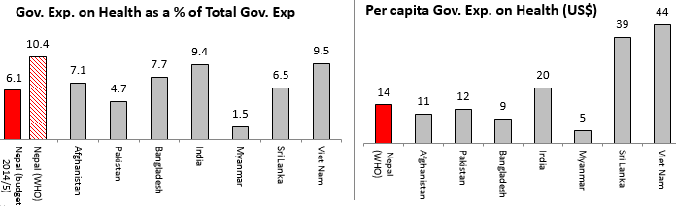

Source: Based on data from Ministry of Finance (2014) and WHO (2014)

Allocation to social protection continues to increase. Fiscal year 2014/5 allocation to social protection is projected to reach to 2.67 per cent of GDP as shown in table 2. This is marginally above the regional average of 2.4 per cent of GDP (World Bank, 2013). However, the bulk of the social protection spending is on formal social security programs to the civil servants, who comprise only a small share of the population. This means that social assistance is biased toward the formal sector, and towards male employees (Koehler 2014b). Nevertheless, the social assistance program increased significantly over the past few years and is projected to increase by 17.82 per cent in real-term for the fiscal year 2014/15 (Ministry of Finance, 2014).

Figure 22: Distribution of the Social Protection Allocation across the Different Programs, 2014/15.

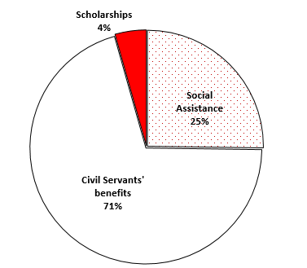

Source: Based on data from Ministry of Finance (2014)

Looking at the options for reprioritizing expenditures, the shares and per capita spending on the social sector side are low. However, spending on economic infrastructure is also crucial. Well-functioning transportation networks, energy, or communications are prerequisites to economic development, productivity enhancement, and income poverty reduction, and moreover are necessary for access to social services. An expenditure shift between the social and economic sectors, or among the social sector areas is not advisable. However, a further decrease in defence expenditures could free up existing government resources for the social sector.

**6.3 More accommodating macroeconomic framework**

A second option for enhancing fiscal space on the expenditure side is to introduce an expansionary fiscal and monetary policy framework. This option includes two main instruments: 1- tolerance of a higher budget deficit and; 2- higher levels of inflation.

Regarding the budget deficit, Nepal over the past couple of years enjoyed a budget surplus due to improved taxation combined with low budget execution levels, especially with respect to expenditure on the capital budget. As a result, Nepal enjoys a low public debt projected to decline to only 29.70 per cent of GDP by end of fiscal year 2014/5 (Ministry of Finance, 2014), which is half of the ratio of around 60 per cent a decade ago (IMF, 2014). It also compares favourably with regional comparators. Given the low public debt in Nepal, the IMF’s recent assessment indicates a modest expansion is affordable without endangering debt sustainability.

Figure 23: General Government Gross National Debt as a per cent of GDP, 2013

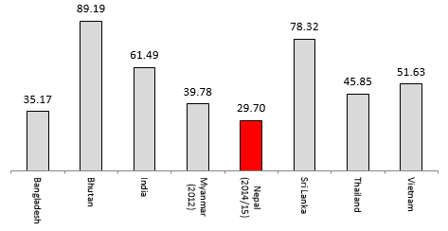

Source: Based on data from Ministry of Finance (2014) and IMF (2014).

Regarding higher levels of inflation, this option would be less desirable, given the relatively high inflation rates averaged 9.24 per cent over the period 2010-1024 (IMF, 2013). Inflation impacts on the lowest income groups the most, if staples foods and basic goods and services are not protected from price rises. It is worth noting that the Nepali rupee’s peg to Indian rupee and the close trade relationship with India creates some benefits, in terms of stability of cross border trade prices but also carries the risk of inflation. For instance, an IMF econometric analysis finds that the Indian inflation is the key driver of Nepali inflation, with one per cent increase in India’s inflation leading to 0.45 per cent increase in Nepali inflation (IMF, 2014).

**6.4 Using fiscal and central bank foreign exchange reserves**

A further option on the expenditure includes two main sources: the first option is mobilising fiscal reserves including savings from budget surpluses and other state revenues. The second option is to utilise foreign exchange reserves in the central bank.

The improved tax/GDP ratio, increased grants to the budget, coupled with low rates of budget execution, especially on the capital budget, have continued to build up budget. The fiscal year 2014/15 projected a slight budget increase in an effort to accelerate capital spending discussed earlier. There is certainly fiscal space to be gained here also for expenditures on the social sector, both in terms of capital and current expenditures.

Foreign exchange reserves are accumulated through foreign exchange market interventions by central banks within the context of current account surpluses and/or capital inflows. Countries build up foreign exchange reserves usually to self-insure against economic and financial shocks and also as part of broader efforts to stabilize the macro-economy, especially exchange rates (Ortiz, Chai, & Cummins, 2011). Continuation of growth in remittance inflows, estimated to have reached about 30 per cent of GDP in 2013/14 as compared with only 9 per cent of GDP in 2000, has boosted the build-up of Nepal’s Net International Reserve, which is currently totalling US$ 5.846 billion as of March 2014 (IMF, 2014).

Figure 24: Workers' Remittances and Gross Official Reserves, Millions USD, 2010/11- 2014/15

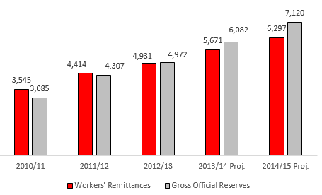

Source: Based on data from IMF (2014).

By any measures, the gross official reserves are very high. For instance, it covers almost 8.1 months of prospective imports as of March 2014 (IMF, 2014) - significantly higher than the three-month safe level benchmark. The IMF also projected the fiscal reserve to continue to build up, but at a lower rate. With low public debt in Nepal, the government has an ample room to create fiscal space by borrowing form the central bank’s reserve to increase public spending.

* 1. **Increased aid and transfers**

In addition to the remittances inflow discussed earlier, Nepal continues to benefit from inflows of grants. As shown in table 2, grants are projected to amount 3.6 per cent of GDP for fiscal year 2014/15. Most of the grants are directed to recurrent spending.

Figure 25: Grants Billion Nepali Rupees (NRs.) and as a per cent of GDP, 2012/13-2014/15[19]

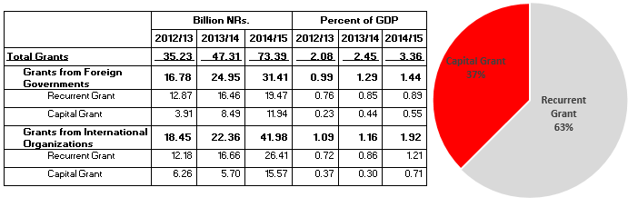

Source: Based on data from Ministry of Finance (2014)

In addition to legal financial flows, curtailing illicit financial flows (IFFs) could also free up additional resources. IFFs involve capital that is illegally earned, transferred or utilized and include, inter alia, traded goods that are mispriced to avoid higher tariffs, wealth funnelled to offshore accounts to evade income taxes and unreported movements of cash (Ortiz, Chai, & Cummins, 2011). A study estimated on average IFFs outflow from Nepal between 2000-2008 to have totalled US$ 563 million annually (Dev Kar & Curcio, 2011), which is about 7.12 per cent of GDP over the same period.

1. **policy recommendations and way forward**

The study has illustrated the considerable impact of the current Child Grant on child nutrition, birth registration, and its potential impact on economic growth. The study has also illustrated with a range of cost scenarios that the expenditures on an enhanced Child Grant would be affordable, and identified options for increasing fiscal space (the summary results from the projection is presented in table below). It argues that there would be a favorable impact on children, and a case can be made that the effects could also be beneficial politically.

Based on these findings, it makes the case for further scaling up and enhancing the current Child Grant. The recommendations are on two levels. Firstly, in terms of coverage, it is recommended to universalize the Child Grant, making it a keystone of the Social Protection Floor Framework. Secondly, at the design level, it is recommended to augment the benefit amounts to enhance the impact and strengthen the monitoring and evaluation system. The proposed benefit amount will also be par to other social protection schemes such as old age and widow allowance.

The study furthermore proposes changing the age eligibility, such that coverage would move forward into the pregnancy phase. In that connection, one option for consideration would be to adjust eligibility, moving from the current Child Grant format of “nought to 5” to one that goes from pregnancy to 2 years. The rationale for such a model would be that this is the most vulnerable phase in an infant’s life, would support women during pregnancy and breastfeeding periods, and that a shorter time period would make way for higher benefit amounts, which would enable a more tangible contribution to the household income. The coverage of total children will reduce and cost will also be reduced.

Table : Summary Results from the Projection of Costs and Number of Beneficiaries

|  |  |  |  |  |  |  |  |
| --- | --- | --- | --- | --- | --- | --- | --- |
| Eligibility | Amount (NRs, monthly) | Number of Beneficiaries (in thousands) | | Expenditure  (Billion NRs) | | Expenditure  (% of GDP) | |
| **2014** | **2020** | **2014** | **2020** | **2014** | **2020** |
| **Under 5** | 200 | 2,282 | 2,229 | 6.57 | 9.54 | 0.34 | 0.26 |
| 300 | 9.86 | 14.31 | 0.5 | 0.39 |
| 500 | 16.43 | 23.85 | 0.84 | 0.65 |
| **1000 Days  (From Pregnancy until Under 2)** | 500 | 1,315 | 1,392 | 7.63 | 11.97 | 0.39 | 0.33 |
| 750 | 11.46 | 17.95 | 0.59 | 0.48 |
| 1000 | 15.28 | 23.94 | 0.78 | 0.64 |

**7.1 Strategies towards Universalization**

If immediate universalization is not possible for political or fiscal reasons, it is proposed to set a defined, agreed and realistic timeline for its progressive realization. Universalization could in that case be achieved by continuously expanding geographical targeting. For example, the Child Grant could be maintained at a universal level in the Karnali region as the poorest region of the country, and extended district by district over a defined period of time. The extension could proceed progressively and continuously, from worst-off to better off districts, measured by an indicator considered most appropriate, and that is at the same time easily available and periodically updated. There are a host of identification criteria to choose from for sequencing among the districts. They include the national poverty line or poverty head count data, using the Nepal Living Standard Survey (NLSS) findings; GDP per capita; malnutrition and food insecurity mapping (for example the Vulnerability Analysis and Mapping undertaken by WFP) (WFP 2014); the human development index (HDI), gender development index (GDI) or the human poverty index of UNDP (UNDP and GoN 2014); or the multidimensional poverty index of the Oxford Poverty and Human Development Initiative (OPHI 2011). Most of these indicators identify the same districts as most disadvantaged, and the selection decision could cross-reference several of the indicators, so as to be analytical and transparent.

Even if the government were to decide to keep the total fiscal budget allocation to the Child Grant program constant over the next few years, there are nevertheless some attractive options. One would be, as mentioned above, to adjust age coverage by shortening it to cover 1000 days (pregnancy until under age 2). By doing so, the benefit amount can be increased considerably as the number of beneficiaries decreases. Since a major shortcoming of the current model is that the benefit level is very low, this could of itself represent an improvement. It would however need to be weighed against the shorter overall coverage period. Further, ensuring early birth registration and application for the grant is crucial to reach the youngest children reliably and quickly, given the relatively lower coverage rate under the current scheme. Including expecting mothers helps to boost birth registration and coverage of the grants among infants.

Gender-, caste- and ethnicity based disadvantages tend to intersect and to cluster in the economically poorest regions. Thus, geographical targeting could achieve the effect of addressing child poverty and improving child wellbeing, without stigmatising individual communities and families. Moreover, moving from the worst off to the better off districts over time would mobilize a sense of social justice and social solidarity, and be politically easy to understand.

One technical issue is the change in eligibility ages. If the Government were to adopt the 1000 days model, some families would become ineligible for the Child Grant. The new policy would need to specify that it would be applicable only to infants born after its introduction. In other words, the current grant for all children under five years of age in Karnali and for poor Dalit children would need to remain in place until all children born during that policy reach the age of 5, to honour the government’s commitment and not create upheaval.

**7.2 Monitoring and Evaluation**

Alongside the expansion of the Child Grant, monitoring and evaluation are central to the scale-up strategy. Systematic and frequent monitoring can address the institutional problems raised in recent evaluations, such as delay in delivery, exclusion of eligible population and transfer of inadequate amount (GoN, UNICEF, and VaRG Forthcoming; Adhikari et al 2014; IDS 2014). Collecting and analysing real-time information will not only help identifying problems related to program implementation, but will also create a great database that can be used for further improvement of the program. The following monitoring tools should be considered:

* A Management and Information System (MIS) would collect information on the recipients, frequency and amount of transfers, and progress on complementary programmes. The system has already been developed by the MoFALD.
* Sample-based site monitoring or spot checking, to conduct interviews with participants (including eligible but excluded families) and program officials;[20]
* Periodical report generation form the MIS system, to allow assessment and further analysis by experts at the local and central levels. [21]

At the same time, district officials, VDC secretaries, and social mobilizers will need to be trained on the effective use of MIS, data collection and management and reporting.

Other cash transfer programmes have started to pilot payments through branchless banking methods to increase the efficiency and transparency of payments. These programmes include Social Safety Net Project by MoFALD in Banke, Surkhet and Baglung, Human Development and Social Protection Pilot by United Nations Capital Development Fund in Kanchanpur and Dadeldhura and Cash for Work by World Food Programme (WFP) in Dailekh and Doti (MoFALD, 2014; WFP, 2013). It is yet too early to conclude if modern payment methods contributed to decrease inclusion and exclusion errors as we lack sufficient data to evaluate the pilot programs. Some challenges were surfaced through the projects, including: technical limitations (missing internet connectivity, lack of electricity and difficulties in reading fingerprints); liquidity and logistical challenges in remote hills and mountains; challenges to find qualified agents who are responsible to pay the recipients directly, and to provide incentives for them to build sustainable relationship; and communication challenges both among the multiple policy stakeholders and to the beneficiaries (MoFALD, 2014).

Collecting the empirical evidence on the effect of the Child Grant is also crucial to build broad political and public support for the expansion and continuation of the program. For solid impact evaluation, it is necessary to collect baseline information while expanding the Child Grant to be able to compare and measure the impact. The data should be analysed using rigorous statistical and econometrics tools, enabling the government to identify the impact of the child grant itself, isolated from other factors.

Not surprisingly, cash transfers in other countries are found to have positive institutional externalities (Fiszbein, Schady, & Ferreira, 2009). Through their emphasis on monitoring and evaluation, cash transfer programmes have strengthened a results culture within the public sector. Also in the context of Nepal, it is expected that establishing a robust monitoring and evaluation system for social protection schemes including Child Grant will have cross-sectoral external effects to strengthen other policy implementation.

* 1. **Conclusion**

In closing, it is reiterated that the best possible social protection for children in Nepal needs to be made available because of the Government’s commitments from the CRC, the Interim Constitution, the National Plan 2013-2016, and other policy statements. There is a compelling case that reform of the CG is one of the most effective and practical ways to achieve this. It would be crucial to do this with urgency but effectively and with transparency and predictability. From a fiscal resource point of view, this is entirely feasible. From an impact point of view, it would be effective. From a child rights point of view, it is imperative.

As a next step, it is recommended to conduct an analysis on the performance of the individual parts of the Social Protection system (policies and programmes, institutions, schemes and benefits) and their combined performance in relation to resource allocation to identify fiscal space and efficiency gains that can be resulted from a consolidated system of social protection. This will provide concrete evidence and contribute with clarity for policy makers to better assess opportunities and potential challenges in increasing the coverage and depth of certain programs and increasing the scope and synergies across different programs.

Annex: Overview of Social Protection Programmes in Nepal[22]

|  |  |  |
| --- | --- | --- |
| **Programme** | **Benefit** | **Implementing Arrangement** |
| **1. Cash Transfers** |  |  |
| Senior Citizens Allowance | All persons aged 70+ receive Rs 500/month | Ministry of Women Child and Social Welfare (MOWCSW)/ Minisry of Federal Affairs and Local Development (MoFALD) |
| Single women's’ Allowance | Widows, Dalits and Karnali residents aged 60+ receive Rs 500/month | MOWCSW/MOFALD |
| Disability Allowance | Disabled persons 16+ receive Rs 1000/month (fully disabled), Rs 300/month for partially handicapped | MOWCSW/MOFALD |
| Endangered Ethnicities Allowance | All household members receive Rs 500/month | MOWCSW/MOFALD |
| Child Protection Grant | Rs 200/month per child under 5 for up to 2 children for poor Dalit families and all families in Karnali | MOWCSW/MOFALD |
| Maternity Incentive Scheme (CCT) | Pregnant women receive Rs 500 in Tarai, Rs 1000 in Hills and Rs 1500 in mountains as transportation costs plus Rs 300 provided to health professionals and Rs 1000 reimbursement to facilities.  Also free delivery care in 25 low HDI districts. | Ministry of Health and Population (MOHP)/DFID |
| Senior Citizen Health Treatment Programme | Cash transfers to senior citizens above 65 years | MOWCSW |
| Natural disaster emergency relief | Cash and in-kind transfers in flood and landslide affected areas | MOHA |
| Strengthening Decentralized Support for Vulnerable and Conflict-Affected Families and Children (CCT) | 4000 households in 5 districts receive Rs 1000 per  month for 12 months | MOWCSW/ADB |
| Subsistence Allowance for those Martyred or Handicapped in the Conflict | Rs 360,000 million provided to IDPs. Rs. 60,000 per year as livelihood support for families of martyrs with an educational allowance for children up to the age of 18 for up to 3 children.  For those injured during the fighting those with more than 50% disability receive Rs100,000, those injured less than 50% receive Rs 80,000, those fully disabled Rs 200,000 – this is a lump sum amount.  Those with a member of family still declared “disappeared” they receive 100,000 per family.  In addition to the 1 million for those killed, the widows receive Rs 25,000. | MOPR |
| Tax exemption and debt relief | For women, Dalits, disabled, poor farmers, disaster- and conflict-affected | MOF and national banks |
| **2. In-Kind Transfers** | **Benefit** | **Implementing Arrangement** |
| Conditional In Kind Transfer through Food and Cash for Assets activity | Food and cash is provided to highly food insecure households through an asset creation programme. This programme also creates opportunities for improved agriculture production in food insecure district | MoFALD/World Food Programme (WFP) |
| Public Food Distribution System | Food storage/distribution in select districts | MOAC,MOCS, Nepal Food Cooperation,WFP |
| School Meal Programme and Maternal Child Health Care Programme | School children are provided with nutritious mid-day meals and pregnant and lactating women and young children provided with take-home rations of nutritious food | MOE, MOHP, WFP |
| Karnali Fortified Food Distribution Programme | All children aged 6-23 months in Karnali are provided with a nutritious food supplements. | MOHP |
| Iodized Salt Distribution | Supply of salt to boost nutrition | MOHP and Salt Trading Corportaion |
| **3. Access to Services** | **Benefit** | **Implementing Arrangement** |
| Education for All | Dalits, Karnali children, girls, children from marginalized groups, conflict-affected children and children with disabilities receive scholarships.  Representation of socially marginalized parents in the school management committees and parent teachers association and increased gender representation. | MOE |
| Free Heath Services | Free services in health posts and sub health posts, primary health centres and district hospitals for primary health treatment. 40 listed drugs are available free of cost. Free maternity services. Free dialysis and cancer treatment for endangered indigenous communities, citizens over 75 and children under 15 years of age. | MOHP |
| Housing programme | 1000 Dalit and Muslim households in 3 Tarai districts are provided with low-cost housing | MOPPW |
| **4. Social insurance** | **Benefit** | **Implementing Arrangement** |
| Employee Provident Fund | Workers in Government, Organizations with 10+ employees receive pension and work-related disability payments depending on contribution | Government of Nepal |
| Gratuity | Employees serving 3 years or more and retiring are entitled to gratuities at different rates depending on years of service | GON |
| Civil Service Pension Scheme | Civil servants with 20+ years service, armed forces personnel with 16+ years service receive monthly benefits and lump sums based on service and salary | Government of Nepal |
| Work Injury Insurance | Mine workers , organizations with 10+ employees receive lump sums based on salary and service | Government of Nepal |
| Citizens Investment Fund | Formal sector workers receive returns on voluntary investments | Government of Nepal |
| **5. Public Works** | **Benefit** | **Implementing Arrangement** |
| Rural Community Infrastructure Works | 295,000 households receive cash or food in return for 50-70 days employment annually in unskilled and low skilled public works | MOFALD/WFP |
| Karnali Employment Programme | Aims to provide 100 days employment for 100,000 people in Karnali | MOFALD |
| Youth Self-Employment Scheme | 100,000 youth and adults to receive 100 days employment | MLTM |
| **6. Employment/**  **Skills Development programmes** | **Benefit** | **Implementing Arrangement** |
| Poverty Alleviation Programme | Poor people provided with employment opportunities | NPC/WB |
| Technical and Vocational Education Training (TVET) | Skills training for poor and disabled people | MOE, MLTM |
| Assisted Migration | Subsidized loans for economic migrants | MOLTM |
| Technical Education for Dalits and Poor Girls | Skills Oriented Training | MOE |
| Child Labour Elimination and Child Labour Reform Programme | Child rights protection | MOLTM |
| **7.Livelihood Programmes** | **Benefit** | **Implementing Arrangement** |
| Ultra poor programme | Income generation support in 10 districts | MOAC |
| Fertilizer and seed transportation subsidy | Ongoing programme in 14 districts | MOAC |
| Subsidy on chemical fertilizer | 100,000 tonnes of fertilizer provided per year to farmers with less than 4 bigha of land in the terai and less than 15 ropani of land in the hills | MOAC |
| Community Livestock Programme | Income generation support for Dalit and Kamaiya families | MOAC |
| Kamaiya and Haliya rehabilitation programme | Land access to landless and historically marginalized households | MOLRM |
| Leasehold forestry programme | Land access provide to food-insecure communities living in areas adjacent to degraded forest | MOFSC |
| **8. Care Services** | **Benefit** | **Implementing Arrangement** |
| Social care services for children, senior citizens, PWDs and women | Services for poverty and vulnerability reduction | MOWCSW, MOHP, MOE |
| **9. Others** | **Benefit** | **Implementing Arrangement** |
| Special Provisions for people with disabilities | 50 per cent discount on transport fare in public land transport, domestic flight.  Free health check up to persons with disabilities in government hospital  5 per cent quota reservation in civil service and 4% in private sectors company (according to the disabled protection and welfare Act)  Custom tax waiver to import the specially made four wheels scooter and assistive devices for persons with disabilities. | **MoLTM**  **MOHPP**  **MoGA**  **MoF** |

**References**

Adhikari, Tej Prasad et al., *How does social protection contribute to social inclusion in Nepal? Evidence from the Child Grant in the Karnali Region,* ODI and NEPAN, ODI Report February 2014

Alston, Philip, *Report of the Special Rapporteur on extreme poverty and human rights*, United Nations General Assembly, 11 August 2014, New York

Asian Development Bank, *The Social Protection Index: Assessing Results for Asia and the Pacific. Manila,* [<www.adb.org/publications/social-protection-index-assessing-results-asia-and-pacific](http://www.adb.org/publications/social-protection-index-assessing-results-asia-and-pacific)>, 2013, accessed 26 Nov 2014

Barrientos, Armando , Miguel Niño-Zarazú and Mathilde Maitrot Brooks, *Social Assistance in Developing Countries Database*, World Poverty Institute, The University of Manchester, Version 5.0 July 2010, [<papers.ssrn.com/sol3/papers.cfm?abstract_id=1672090](http://papers.ssrn.com/sol3/papers.cfm?abstract_id=1672090)>, accessed 26 Nov 2014.

Bonnerjee, Aniruddha, ‘Social sector spending in South Asia in Development and Welfare Policy in South Asia’*,* in *Development and Welfare Policy in South Asia*, edited by Gabriele Koehler and Deepta Chopra, London Routledge, 2014, p185-197.

Central Bureau of Statistics, *Nepal Living Standards Survey 2010-2011*, 2012, Kathmandu, Nepal.

Central Bureau of Statistics, *Nepal Population and Housing Census 2011*, 2014, Kathmandu Nepal.

Central Bureau of Statistics and UNICEF*, Multiple Indicator Cluster Survey 2014 Key Findings*, Kathmandu, January 2015.

Delany, Aislinn, et al., *Review of the Child Support Grant: Uses, Implementation and Obstacles*, UNICEF, New York, 2008.

Esping-Andersen, Gosta.,*The Three Worlds of Welfare Capitalism*, Polity Press, Cambridge, 1990.

European Commission, *Social Protection in European Union Development Cooperation*, Communication From The Commission To The European Parliament, The Council, The European Economic andd Social Committee and The Committee of The Regions,Brussels, 2012, <www.ipex.eu/IPEXL-WEB/dossier/document/COM20120446.do>, accessed 26 Nov 2014.

Food and Agriculture Organization of the United Nations, *Characterization of small farmers in Asia and the Pacific. Asia and pacific commission on agricultural statistics twenty-third session,* Siem Reap, Cambodia, April 2010, p26-30.

Fiszbein, Ariel., Norbert Schady, and Francisco Ferreira, *Conditional cash transfers: reducing present and future poverty,* World Bank Publication,Washington, D.C, 2009, p15, 27-28.

Government of Nepal, *Three Year Plan Approach Paper* *(2010/11 - 2012/13),* Government of Nepal, Kathmandu, Nepal, August 2010.

Govenment of Nepal, New Era and ICF International, *Nepal DHS, 2011 - Final Report (English)*, Kathmandu, Nepal, 2012.

Government of Nepal, *An Approach Paper To The Thirteenth Plan (FY 2013/14 – 2015/16)*, Government of Nepal, Kathmandu, Nepal. July, 2013.

Government of Nepal, UNICEF and Valley Research Group, *A Cross-Sectional Survey on Reduction of Child Malnutrition through Social Protection Programme in the Karnali Zone of Nepal,* Kathmandu, Nepal, Forthcoming.

Heller, Peter S., *Understanding Fiscal Space.* Washington D.C.: IMF, 2005.

Handayani, Sri Wening., *Enhancing social protection in asia and the pacific: The proceedings of the regional workshop*, Asian Development Bank, Manila, 2010.

International Labour Organization, *Social Protection Floor for a Fair and Inclusive Globalization. Geneve,* Report of the Social Protection Floor Advisory Group, Geneva, 2011.

International Labour Organization, *Social Protection Floors Recommendation. ILO Recommendation 202*, ILO, Geneva, 2012. <[www.ilo.org/dyn/normlex/en/f?p=NORMLEXPUB:12100:0::NO:12100:P12100_INSTRUMENT_ID:3065524:NO](http://www.ilo.org/dyn/normlex/en/f?p=NORMLEXPUB:12100:0::NO:12100:P12100_INSTRUMENT_ID:3065524:NO)> accessed 26 Nov 2014

International Labour Organization, *World Social Protection Report 2014/15. Building economic recovery*, *inclusive development and social justice*, ILO, Geneva, 2014.

International Monetary Fund, *World Economic Outlook Database*, 2013. <[www.imf.org/external/pubs/ft/weo/2013/02/weodata/index.aspx](http://www.imf.org/external/pubs/ft/weo/2013/02/weodata/index.aspx)> accessed 24 Jan 2014.

International Monetary Fund, *Nepal: 2014 Article IV Consultation- Staff Report; Press Release; and Statement by the Excutive Director for Nepal,* IMF, Washington, D.C, 2014.

Kar, Dev., and Karly Curcio, *Illicit Financial Flows from Developing Countries: 2000-2009. Update with a Focus on Asia,* Global Financial Integrity, 2011.

KC, Sony., Upreti, Bishnu., Paudel, Suman., Acharya, Gopikesh., Tandukar, Annal., and Babajanian., Babken, What does Nepal’s Old Age Allowance mean for the elderly? Evidence from Rolpa, *SLRC Briefing Papers*, Nepal Centre for Contemporary Research, Kathmandu, 2014

Khatiwada, Yuba Raj and Gabriele Koehler, ‘Nepal: social policy in a nascent welfare state’ in *Development and Welfare Policy in South Asia*, edited by Gabriele Koehler and Deepta Chopra, London Routledge, 2014, p129-147.

Koehler, Gabriele., and Deepta Chopra. *Development and Welfare Policy in South Asia.* Routledge Explorations in Development Studies. London Routledge, New York, 2014

Köhler, Gabriele, Marta Cali, and Mariana Stirbu, *Social Protection in South Asia:A Review*, UNICEF Regional Office for South Asia, 2009. <www.unicef.org/socialpolicy/files/social_protection_in_south_asia_-_a_review_-_unicef_rosa_2009.pdf> accessed 26 Nov 2014

Koehler Gabriele, ‘Social Protection in Nepal. Challenges and Ideas’ in *UNDP Development Advocate,* UNDP, Year II, Issue 1, April 2014a, p9-13

Koehler Gabriele, *Nepal: A young democracy with much to show but still far to go*, Third World Resurgence, No 285. May 2014b, p30-32

Koehler, Gabriele ‘A welfare geography of South Asia’ in *Development and Welfare Policy in South Asia*, edited by Gabriele Koehler and Deepta Chopra, London Routledge, 2014c, p24-38.

Mathers, Nick and Slater, Rachel, Social Protection and growth: Research synthesis, Overseas Development Institute, 2014

Milanovic, Branko, *The Haves and the Have-Nots: A Brief and Idiosyncratic History of Global Inequality,* Basic Books, New York, 2010.

Ministry of Federal Affairs and Local Development, *Child Friendly Local Governance National Strategy -2068 (2011) and Child Friendly Local Governance: Operational Guideline*, Government of Nepal, Kathmandu, Nepal, 2012.

Ministry of Federal Affairs and Local Development, *Nepal’s Experience with Branchless Banking to Deliver Cash Transfers*. Kathmandu, Nepal, September 17th, 2014.

Ministry of Finance, *Budget Speech of Fiscal year 2009/10*, Government of Nepal, Kathmandu, Nepal, 2009.

Ministry of Finance, *Budget Speech of Fiscal year 2002/13*, Government of Nepal, Kathmandu, Nepal, 2002.

Ministry of Finance, *Budget Speech of Fiscal year 2014/15*, Government of nepal, Kathmandu, Nepal, July 13th, 2014.

National Planning Commission, *Nepal Millennium Development Goals Progress Report*, Government of nepal, Kathmandu, Nepal, 2011.

National Steering Committee on Social Protection Framework*, National Framework for Social Protection (draft)*, Kathmandu, 2012

Okubo, Tomoo, Improving Nutrition through Child Grant: Evidence from Karnali Zone, Nepal, UNICEF-Nepal Working Paper Series, Kathmandu, 2014.

Ortiz, Isabel., Jingqing Chai, and Matthew Cummins, *Identifying Fiscal Space: Options for Social and Economic Development for Children and Poor Households in 182 Countries.* UNICEF, New York, 2011.

Ortiz, Isabel and Matthew Cummins, Beyond the Bottom Billion, *Global Inequality.* UNICEF, New York, 2011. <www.unicef.org/socialpolicy/index_58230.html> accessed 26 Nov 2014.

Oxford Poverty and Human Development Initiative, *Country Briefing: Nepal*

*Multidimensional Poverty Index (MPI) At a Glance*, Cambridge, 2011. [<www.ophi.org.uk/wp-content/uploads/Nepal1.pdf](http://www.ophi.org.uk/wp-content/uploads/Nepal1.pdf)>

Panday, Devendra Raj, *The Legacy of Nepal’s Failed Development’* in *Nepal in Transition* edited byvon Einsiedel, Sebastian, Davi Malone, Suman Pradhan*,*Cambridge University press, 2013, p81-99.

Pandey, Jhabindra. P., *Maternal and Child Health in Nepal: The Effects of Caste,Ethnicity, and Regional Identity: Further analysis of the 2011 Nepal Demographic and Health Survey*, 2013.

Piketty,Thomas, *Capital in the Twenty-First Century,* Harvard University Press. Cambridge, 2014.

Roy, Rathin., Antoine Heuty, and Emmanuel Letouze, *Fiscal Space for What? Analatical Issues from Humand Development Perspectives. Paper for the G20 Workshop on Fiscal Space*. UNDP*,* Istanbul, 2007. [<www.kw.undp.org/content/dam/aplaws/publication/en/publications/poverty-reduction/poverty-website/fiscal-space-for-what/FiscalSpaceforWhat.pdf](http://www.kw.undp.org/content/dam/aplaws/publication/en/publications/poverty-reduction/poverty-website/fiscal-space-for-what/FiscalSpaceforWhat.pdf)>

Roy, Rathin and Antoine Heuty, *Fiscal Space. Policy Options for Financing Human Development*, Earthscan, London, 2009.

Sadoulet, Elisabeth, Alain de Janvry and Benjamin Davis , *Cash transfer programs with income multipliers: PROCAMPO in Mexico.* World development, 2001, p1043-1056.

Sepulveda, Magdalena and Carly Nyst., *The Human Rights Approach to Social Protection, Ministry of Foreign Affairs*, Kathmandu, Nepal, 2012.  
<www.ohchr.org/documents/issues/epoverty/humanrightsapproachtosocialprotection.pdf> accessed 26 Nov 2014

United Nations, Convention on the Rights of the Child, United Nations, New York, November 1989.

United Nations, *High level panel report on the post 2015 development agenda*, New York. May 2013. <www.un.org/sg/management/pdf/HLP_P2015_Report.pdf>

United Nations Department of Economic and Social Affairs, Population Division, World Population Prospects: The 2012 Revision. New York, 2013, Retrieved January 21, 2014, from <http://esa.un.org/unpd/wpp/index.htm>

UN Development Group Asia-Pacific, Social Protection Issues Brief . UNDG Asia-Pacific Social Protection Issues Brief, Prepared by Valerie Schmitt, Qimti Paienjton, and Loveleen De, 2014.

<www.social-protection.org/gimi/gess/RessourcePDF.action?ressource.ressourceId=4537>

United Nations Development Programme, *Human Development Report.* UNDP. New York, 2010.

United Nations Development Programme, *Development Advocate Nepal: In Pursuit of Millennium Development Goals.* Kathmandu, Nepal, 2013.

United Nations Development Programme, *Development Advocate. Leveling the playing field.* April - September 2014. <www.np.undp.org/content/dam/nepal/docs/reports/development_advocate/UNDP_NP_Development-Advocate-Nepal-April2014-September2014.pdf> accessed 26 Nov 2014.

United Nations Development Programme Nepal and Government of Nepal, *Nepal.Human Development Report 2014. Beyond Geography. Unlocking Human Potential,* Kathmandu, Nepal. <www.np.undp.org/content/dam/nepal/docs/reports/hdr/UNDP_NP_Nepal_Human_Development_Report_2014.pdf> accessed 26 Nov 2014.

United Nations Economic and Social Commission for Asia and the Pacific, *The promise of protection. Social Protection and development in Asia and the Pacific,* UN ESCAP, Bangkok, 2011a.

United Nations Economic and Social Commission for Asia and the Pacific, *Situation Report. International Migration in South and South-West Asia,* Asia-Pacific RCM Thematic Working Group on International Migration including Human Trafficking, UN ESCAP, Bangkok, 2011b.

United Nations Children’s Fund, New Era, National Planning Commission, *Child Poverty and Disparities Nepal,*  UNICEF,Kathmandu, Nepal, 2010. <www.unicef.org/rosa/Child_Poverty_Study-_Overview(1).pdf> , accessed 26 Nov 2014.

United Nations Children’s Fund, *Complimentary Programme to Support Implementation of the Child Grant in Karnali Districts, Programme Planning Document.*UNICEF-Nepal, 2010

United Nations Children’s Fund, *Public Finance and Social Budgeting, learning Module.* New York: UNICEF, 2011

United Nations Children’s Fund and Nepal Technical Assistance Group, *Nutrition Assessment Of Children 0-59 Months In The Districts Of Mid & Far Western Regions Of Nepal*. UNICEF Kathmandu, Nepal, 2012.

United Nations Children’s Fund, *Integrated Social Protection Systems: Enhancing Equity for Children. UNICEF Social Protection Strategic Framework,* 2012a. [<www.unicef.org/socialprotection/framework/files/Consultation_Report_THEMATIC-External_Consultation_(PHASE_2)-MARCH2012.pdf](http://www.unicef.org/socialprotection/framework/files/Consultation_Report_THEMATIC-External_Consultation_(PHASE_2)-MARCH2012.pdf)>, accessed 26 Nov 2014

United Nations Children’s Fund, *Inequities in Early Childhood Development: What the data say. Evidence from the Multiple Indicator Cluster Surveys*, UNICEF, New York, 2011b.

United Nations Children’s Fund, *The State of the World’s Children 2014 in numbers: Every child counts,* UNICEF, New York, 2014.

United Nations Children’s Fund, ‘Nutrition in Emergencies’ <[www.unicef.org/nutrition/training](http://www.unicef.org/nutrition/training)>, accessed 19 Nov 2014.

United Nations System Task Team on the Post-2015 Development Agenda. *Social protection: A development priority in the post-2015 UN development agenda. Thematic Think Piece, 2012.*  <www.un.org/millenniumgoals/pdf/Think%20Pieces/16_social_protection.pdf>, accessed 26 Nov 2014

Upreti, Bishnu R., et al., *Researching livelihoods and services affected by conflict, Nepal Center of Contemporary Research, Livelihoods Research Consortium,* Working Paper 7, August 2012, <www.odi.org.uk/sites/odi.org.uk/files/odi-assets/publications-opinion-files/7784.pdf>, accessed 26 Nov 2014

World Bank, *Resilience, Opportunity and Equity*. *The World Bank’s Social Protection and Labor Strategy 2012–2022*, The World Bank, Washington, D.C., 2012.

World Bank, *Nepal Human Development Note: Access, Equity,and Quality in the education, Health and Social Protection Sectors.* Washington: Human Development Unit, South Asia Region. The World Bank, Washington, D.C., 2013.

World Bank, *Nepal: Country Snapshot,* World Bank, Washington, D.C., March, 2014a.

World Bank, *World Development Indicators (WDI),* World Bank, Washington, D.C., *2014* <data.worldbank.org/data-catalog/world-development-indicators> accessed 24 Nov 2014.

World Food Programme, *Food Security Bulletins Nepal*. *2013/2014*, WFP, 2014.

<documents.wfp.org/stellent/groups/public/documents/ena/wfp267322.pdf > accessed 24 Nov 2014.

1. The ADB counts active labour market policies as the third component of social protection.
2. Citation in this section is from Koehler 2014c unless stated otherwise.
3. The SPI an indicator that divides total expenditures on social protection by the total number of intended beneficiaries of all social protection programs. For assessment purposes, this ratio of expenditures to beneficiaries is compared with poverty-line expenditures. For example, if the SPI were 0.100 in country X, this index number would mean that total social protection expenditures (per intended beneficiary) represent 10 per cent of poverty-line expenditures. The higher this index number, the better a country’s performance. ADB 2013: xii
4. TheRemote regions in Nepal, including the Karnali Zone, experiences a particular effect of high food prices due to transportation costs, which may be different from the general level of food price inflation. Therefore, Adhikari et al (2014) recommend pegging the grant to local food prices.
5. These districts are: Jumla, Humla, Dolpa, Kalikot and Mugu.
6. The original intention of the program was to be a universal measure from the start, covering all children in Nepal under the age of 5. Policy discussions decided to introduce a limit of 2 children under 5 per family and budget constraints made it necessary to introduce geographical and categorical targeting.
7. For a more in depth review of the delivery mechanics and their shortcomings, see IDS 2014.
8. UNICEF, through the financial support from ADB, provided technical assistance to develop implementation guidelines, and supported implementation process, including the birth registration. In addition, support was provided in monitoring, evaluation, system strengthening and institutional capacity development of relevant stakeholders including the MoFALD, DDCs and VDCs (UNICEF 2010).
9. These rules included the land ownership, the area of land and productivity of their own land.
10. The evidence was collected from multiple sources and used in the brief (UNICEF, 2010), available at http://www.unicef.org/socialpolicy/files/Social_Protection_Accelerating_the_MDGs_with_Equity(2).pdf
11. Conditional cash transfers are given to beneficiaries conditional on particular behaviors, such as sending children to school or for periodic health check-ups.
12. Examples include a condition for regular and documented school or health centre school attendance, but if schools are too distant, poorly staffed or equipped, attendance requires expenditures, or the environment is abusive, they may not be used.
13. Adhikari et al 2014 found that in the Karnali Zone, households were receiving up to 3 social transfers.
14. Data obtained on July 3. 2014 from the IMF website
15. This chapter is taken from Rabi 2014 unless stated otherwise.
16. The budget for fiscal year 2012/13 is actual, for fiscal year 2013/14 is the revised, and for fiscal year 2014/5 is budgeted.
17. Note that a tax burden analysis is needed to conclude on the impact of the various tax items on different socio-economic group. Also exempting goods/services that are disproportionally consumed by the lower income groups can reduce regressivity and may make the VAT neutral or even progressive, if luxury items are taxed at higher rates.
18. Definitions of health vary across countries. For the sake of comparability, this study uses the WHO data, but also includes the national budget figure for Nepal.
19. The budget for fiscal year 2012/13 is actual, for fiscal year 2013/14 is the revised, and for fiscal year 2014/5 is budgeted.
20. As one example among many, the Familias en Acción program in Columbia provides a successful case for reference ). (Fiszbein, Schady, & Ferreira, 2009).
21. A remarkable example is Mexico’s Oportunidades ). (Fiszbein, Schady, & Ferreira, 2009).
22. Adapted from National Planning Commission’s draft National Framework for Social Protection (2012) and Koehler, Gabriele, UNDP Development Advocate Nepal, Year 2, Issue 1 (2014) p14-15