Towards a progressive and more coherent social policy framework:
A think piece
connecting social development concerns, notions and discourses

Gabriele Köhler

UN DESA Expert Group Meeting on
"Strengthening social development in the contemporary world"
New York, May 2015

This paper is provisional and for discussion. In connection with the current negotaitons on the SDGs and the interest in finding new paths of social development, it attempts to do four things: to look into “social development” at two levels – social development definitions and conceptions of social policy; to search for the missing link of causal analysis; and to explore potentially progressive social policy synergies with respect to the “transformative” ambition of the current social development agenda – the SDGs.

The paper is sketchy, and hopefully provocative.

1) What is social development? Bringing UN discourses and processes together to enhance social policy conceptualisation
The ILO since 1919, the UN secretariat – notably DESA and its precursors - since the 1940s, UNRISD since the 1960s, and UNDP since the 1990s have all been visibly engaged in delineating social development – in the broad sense of that term.

The Charta of the UN in 1945, with respect to social development, posited a goal of well-being, and committed the international community to strive for “higher standards of living, full employment, and conditions of economic and social progress and development” (UN 1945, article 55). Each of the UN development decades, in place from the 1960s through the 1990s, covered economic and social development; environmental considerations emerged - gingerly at first and then ever more pronounced - from the 1970s onwards (Koehler 2015b forthcoming).

Skipping several decades, one moves to the end of the cold war when discourse in the UN became more open and creative, after years of political stalemate, and relaunched into a more critical mode, after succumbing to the neoliberal onslaught of the 1980s. Looking at these past 25 years, then, one observes a series of definitional contributions from the UN system, within a somewhat oscillating notion of social development – from broader to narrower to broader (see fig. 1).

Fig. 1. Evolution of notions of social development
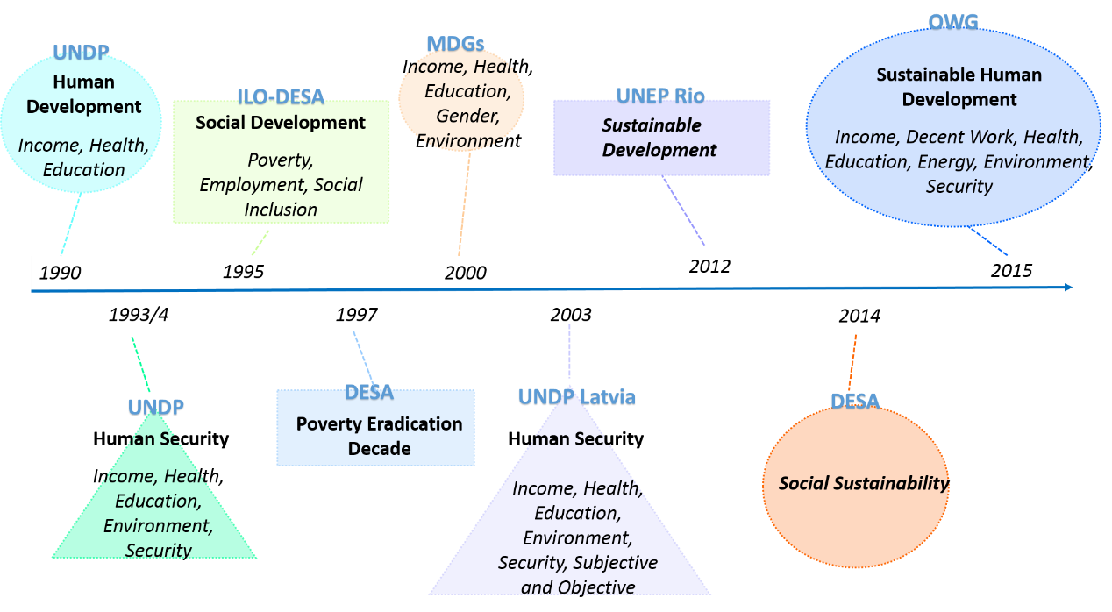

Source: author

The concept of human development arrived exactly in 1990, with UNDP’s first Human Development Report (HDR). That report was seminal: it broke with the GDP-fixated notions of development, and was also an attack on the destructive impacts of structural adjustment politics. It defines human development as “a process of enlarging people's choices. The most critical of these wide-ranging choices are to live a long and healthy life, to be educated and to have access to resources needed for a decent standard of living. Additional choices include political freedom, guaranteed human rights and personal self-respect.” (UNDP 1990: 1). In other words, this was a three-pronged approach to social development, factoring in the economic – income - , the social – health and education, and the political - human rights.

The human development paradigm was complemented briefly thereafter by the five-pronged notion of human security, outlined as related to “job security, income security, health security, environmental security, and security from crime”, also presented by UNDP, building on post-war notions of freedom from fear and freedom from want (UNDP 1994: 3; Koehler 2105b). With this, human development was deepened, by acknowledging that fear and the lack of security impact destructively on human development. Human security later received another dimension with the attention to both objective factors and subjective perceptions of security (UNDP Latvia 2003).

So human development/human security as one trajectory of social development-relevant definitions used a broad, multi-pronged and two-dimensional understanding. Intriguingly, however, UNDP never used the term social development – even in the 1994 HDR, which was directly addressed to the UN’s World Social Summit.

A second strand from within the UN secretariat stuck to the term “social development”. At the 1995 Social Summit, it projected a comprehensive approach to social development, covering social justice, the “material and spiritual needs of individuals, their families and the communities”, economic development, social development and environmental protection. At the operational level, that Summit, in its outcome documents, defined three central “social development goals”: eradicating poverty, promoting full and productive employment, and enhancing social integration.” (UN 1995, article 7). These remain the orientation for UN DESA’s work on social development, as well as informing the ILO research and advocacy on decent work and social inclusion. This strand is less explicit on human rights, although social integration is paired with participation and thus calls for the observation of civil and political rights.

There were two spinoffs from the World Social Summit, one radical, one populist. The radical spinoff is the poverty eradication decades (PEDs). The first of these (1997-2006), saw “economic development, social development and environmental protection” as distinct but interdependent areas (UN GA 1995: 2). Both PEDs place poverty eradication at the centre, counting on decent work and structural policies to achieve this. Intriguingly, they are barely referred to in current social development or social policy dialogues, despite a UN General Assembly reporting process. Are they too progressive?
Fig. 2. World Social Summit spinoffs
The second spinoff was the MDGs, which in 2000/2002 summarised and synthesised the outcomes of the many – indeed progressive - UN summits of the 1990s, including the World Social Summit. As has been widely discussed, the MDGs injected a strong emphasis on social – as compared to economic – concerns into the development debate.

Source: the author
Without explicitly offering a definition of social development, the remit of social development can be inferred from the seven MDG goals. The MDGs, though in terms of genealogy stemming from the Social Summit, watered down many of the commitments and ambitions of the Summit, notably regarding poverty. They shifted the ambition from “eradication” to merely a reduction by half, and put central emphasis on health, education and gender equality, as opposed to decent work - let alone structural reform of the international trade, investment and finance regimes. But they were highly successful as a movement, engaging international discourse, informing national policy making and mobilising financial resources. The MDGs were popular because in a way they were populist.
Moving forward to 2012 and the Rio plus 20 UN Conference on Sustainable Development, one observes contradictory trends. That conference’s outcome text “We the Peoples” (UN 2012) does not use the term social development, but in connection with the SDGs, the term sustainable development marks a return to a broader understanding of social development at the conceptual level. The SDGs are to “promote sustained and inclusive economic growth, social development and environmental protection“ (OWG 2014, article 4). Interestingly, neither of the terms - social development or human development – feature in the SDG text, instead the term used here is sustainable development.
2) What is social policy? Comparing academic and UN positions
Following the above argument, a reflection on social development intersects with a reflection on the contours of social policy. At least two types of definitional approaches can be made out.
The first defines social policy, in a “Nordic” welfare state tradition, as policies to secure basic social services - education, health and other public goods and services, including income security, and in some cases housing. What stands out in this “school” of social policy is the built-in role ascribed to the state. Keynes (1935) and Beveridge (1942) arguably set the stage for this politically. Esping-Andersen (1990) laid the ground from an inventory and classification point of view; Musgrave and Musgrave (1989) had done this with their theory and practice of public goods. The UN development decades were of these traditions. When thought through in consequence, situating social policy within a welfare state concept means a rights-based approach (Jonsson 2003; Cornwall and Nyambu-Musembi 2004), because it deducts the notion of public goods/services from the rights of the citizen, and makes the government the duty bearer accountable for its action.
A second strand of literature organises its understanding of social policy around intended outcomes. Mkandawire and UNRISD for example see redistributive, protective, developmental and transformative functions of social policy (Mkandawire 2004: 12). In its redistributive role, social policy can facilitate better capacity utilisation and broaden domestic markets – the Keynesian argument (Mkandawire 2004: 19). It can contribute to political stability if it lessens conflict and provides a notion of citizenship and decreases outlays for security etc. (ibid 19f). In developing countries, social policy overall can create positive externalities via expenditures on health and education which enable an economy to progress into higher productivity; social protection, as one specific area of social policy, helps enhance human capital, and at the same time makes structural change more acceptable (Mkandawire 2004: 23). Similarly, but with more individualistic categories, Sen’s capabilities approach looks at outcomes on human development. Economic and social policies are those that contribute or are seen to contribute to achieving better human development outcomes.
This approach can be used inductively, analysing the types of challenges facing society, and ascribing social policy areas to each of these challenges. UN DESA in each of its Reports on the World Social Situation tackles a particular socioeconomic challenge. It can be situated in this school of thought. Table 1 (appendix) is an attempt to position the main social concerns in an analytical framework, as a means of classifying social policy areas.
The SDG draft, laying out the next development agenda, could be understood as a synthesis of a rights-based welfare-state approach and an outcome-focussed approach. More on that later.
3) The missing link: causal analysis
Why this rather pedantic review of definitions? Why does it matter?
It matters for three reasons. Firstly, it matters for policy conceptualisation and therefore ultimately for social policy implementation: how social/human development is conceived has a profound impact on policy formulation since it defines the boundaries of social policy and at least implicitly also lays out some objectives. That in turn shapes what is meant to be or – ideally - actually delivered. This is crucial at a juncture when a – notionally new and “transformative” social development agenda is negotiated.
Secondly it matters for policy cohesion in the UN system. The cursory sketch has shown that different parts of the UN system – notionally committed to the same set of principles of wellbeing and a comprehensive, rights-based, and thus hopefully progressive understanding of social development - are not speaking the same terminological language. Perhaps the awareness of common moral roots in the UN Charta has gone missing? The UN system has been subjected to so much competition for impact and for resources, that agencies are not in cohesion among each other and are losing sight of the common vision. While terminological debates cannot reverse that trend of themselves, they can make the need for discourse visible. That could in turn enable the UN as a system return to a visionary approach and role.
But definitions of social development and notions of the content or scope of social policy matter for a third reason that go beyond the “definitional,” and reach into the explanatory or analytical. Both the theories of social development and the schools of social policy presented above eschew the fundamental issue of causation.
However, the rallying cry in the current SDG discussions and negotiations for a transformative agenda implicitly acknowledge that the “world we want” is far removed from the world we have. Income and wealth inequities are at unprecedented levels (Milanovic 2011; Piketty 2014; OXFAM 2015). Globalisation as a mode of production has facilitated global production with an unchecked exploitation of people. Neo-liberalism as an ideology has weakened the role of the state in delivering public goods and services – in other words, curbing its ability for delivering doing social policy, and has ushered in an era of ruthless austerity. The degradation and exploitation of the environment is threatening to destroy the planet (Klein 2014). The socio-economic and ecological processes converge. They can be given different designations, but certainly point in the direction of unfettered capitalism and its logic of unlimited, profit-driven economic growth. It is interesting to note that UN research as well as UN-related conference outcomes shy away from the concept of capitalism. This term, in a critical usage, is however currently experiencing a comeback in other fora.
Building on the ethics of the degrowth movement for example, one could take a normative stance and position progressive social policy as one that subordinates economic activity to social equity and ecological sustainability, thus creating a new, reversed hierarchy of social norms (Van Griethuysen 2012: 264). This would mean flipping the capitalist rationale on its head.
4) The scope for - progressive - social policy in the SDG era
Two fundamental questions arise then. The first-level question is whether the SDGs with their 17 goal areas offer an entry point for holistic social development and social policy that would address social development in the broadly understood sense terms of social sustainability and sustainable human development (see fig 1.1)? And the second, deeper question is whether the implementation of the SDGs would usher in a reversed hierarchy of social equity norms (Van Griethuysen 2012: 264). These questions can be asked because the SDGs have been advertised as “transformative” (OWG 2014).
Taking them by their word, four potential areas of synergies come to mind; there are surely many others.
- Linking employment/decent work and sustainable development
Often, sustainable development is linked with the green economy. This can be misleading. Commercially-driven investment in renewables energy or concomitant technologies for example may or may not be environmentally compatible in the sense of being resource- and energy-neutral.
The spirit of common but differentiated responsibilities needs to apply in this area, adopting a notion of climate justice between the North and the South, and between the wealthy and those living in poverty in North and South. In economically highly developed countries, GDP growth definitely needs to be queried. In a series of political decisions, an approach compatible with sustainability would first call for energy conservation, then freezing the level of energy use, and then systematically and predictably reducing per capita energy consumption. A comprehensive understanding of sustainable development moreover needs to integrate reflections from the climate justice and de-growth schools of thought (See http://www.degrowth.de/en/summer-school-2015/programme/.)
GDP growth would then, statistically speaking, come from a shift from the production of value in the primary and secondary sectors to the creation of value in the tertiary sector, and hence the migration of employment from resource-intensive material production to public goods and services and care services. The sharing movement could provide one example. It is devoted to recycling and up-cycling goods, instead of supporting an infinite extension of material production, and instead moving into services. This includes swapping time instead of producing ever more objects and could illustrate this idea (see Fig 3.).
Fig. 3. An illustration of the sharing economy
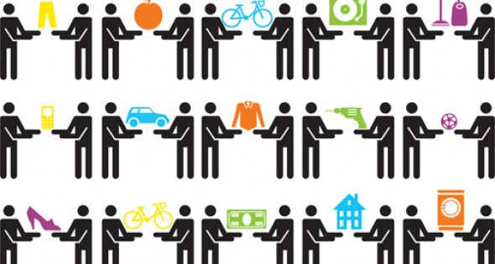

Source https://www.google.com/search?q=sharing+economy

Another related but larger and more systematic movement is that of the social and solidarity economy which encompasses the cooperative and social business sectors.
Redistribution would become a key element - a redistribution of material resource and energy use, of incomes and of wealth. Employment would also be redistributed - from those who work too much to those who have no decent employment and work in the informal sector as casualised labour. Time budgets would need to be adjusted in gender and age-just ways.
In this connection, it would be interesting to juxtapose the burnout syndrome suffered by many people who are in (some type of) over-demanding employment, with the high level of unemployment tolerated. The extent of youth unemployment globally is well-documented and criticised. Conversely, overall high unemployment levels are no longer subject to public protest. As one example, public policy discourse in Germany has come to accept 4 per cent unemployment as “normal” whereas it used to be at the level of frictional unemployment around 2 per cent (See fig. 4).
Fig. 4. Unemployment long term picture, Germany 1950-2015
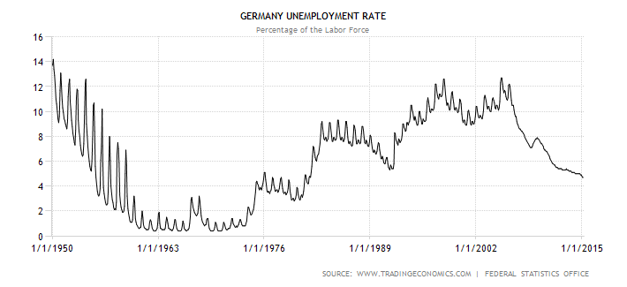
Source http://www.tradingeconomics.com/germany/unemployment-rate
Obviously, this approach applies to the high-income “North”. GDP growth, overall and per capita, including in the form of material goods, remains an urgent necessity in most low-income countries (and even more so in countries or regions devastated by disasters).
Ultimately, social policy could be about adjusting capitalism and abandoning, or at least, dislodging the primacy of the profit motif, and changing the normative hierarchy. But this would need to be at different speeds and patterns in different parts of the world.
- Linking employment/decent work and the care economy.
Making the care economy visible is another policy area with transformative potential. The driving momentum of care must remain in the personal domain, but needs to be redistributed between the genders and across the age groups to ensure equity – equity in pleasure and equity in burden sharing of the activities undertaken in the care domain.
Other elements of the care economy need to become monetised and remunerated. This may imply they would become subsumed under the capitalist rationale, because in a capitalist context, payment is the easiest way to receive recognition and be valued.
In any case, this policy area lends itself to a rethinking and creative linking of the seemingly disconnected objectives of full productive employment and decent work, the role of the care economy, and the role of the state in delivering public services. Expanding paid care work that is in the public sector could provide dignified, respected, decent and properly paid workplaces etc. in crèches, schools, the health sector, and the care sector proper – of young children, people with physical or mental care needs, and the aged. At the same time, it would fulfil other social development objectives.
In the SDG draft, health care services (SDGs 3.7, 3.8) and pre- primary school care services (4.2) are listed in this vein. There is transformative potential in the cluster of recommendations regarding gender equality and empowerment. For example, SDG 5.4 directly tackles the care economy with its recommendation: “Recognize and value unpaid care and domestic work through the provision of public services, infrastructure and social protection policies and the promotion of shared responsibility within the household and the family as nationally appropriate”. (OWG 2014).
- Linking employment/decent work and minimum income guarantees
A third conceptual pathway for transformation is the link between a guaranteed tax-financed social protection floor with an income component in place that assures a minimum income above the median poverty line, and the commitment to decent work.
With respect to incomes, the SDGs, as formulated, are not at all transformative in that the income poverty line is accepted at $1.25 per person per day, PPP adjusted, in 15 ! years from now. This is unacceptable, as there is not economic reason to accept abject poverty. It could be abolished immediately; this is a matter of political will.
At the policy design level, however, the SDG draft includes social protection (floors) (in SDGs 1.3, 5.4, and 10.4.). This is important, since, with a floor in place, poverty could be reduced – provided the transfer benefit is sufficient – and moreover there could be a Keynesian-type effect on demand for goods and services, and hence on employment. At the same time, minimum income guarantees would imply that individuals have a choice and a bargaining position in accepting or rejecting employment, so that the prospects for having decent work could improve.
It is of interest to note that the social protection floor movement has been quite successful in terms of its positioning in global discourse, compared to the agenda around decent jobs and decent work. While value chains are mentioned in the SDGs, their – current- highly exploitative nature is not discussed, missing a major opportunity for transformative or progressive policymaking.
- Sustainable consumption and production and social policy
A fourth area for potentially progressive social policy is in the area of sustainable production and consumption. Movements for sustainability and those for social justice could be connected. One example is the proposed coming together of social and ecological movements. There could for example be to link the movement for free public transport - which is in a way a form of a social protection floor - with efforts to move from individualised transportation in private vehicles to public transport which is energy efficient and CO2 neutral (Klein 2014). - However, overall, as pointed out above, this SDG goal 12 collides directly with the SDG goal around growth.

Concluding thoughts
Connecting social development concerns, notions and discourses could perhaps help move towards a progressive and more coherent social policy framework. Adding a recognition of the nature of capitalism as driving the inequities of the socio-economic and destruction of the planetary system could make the SDGs transformative. Reversing the hierarchy has yet to happen.

Selected references
Beveridge, W. (1942). Beveridge Report. Social Insurance and Allied Services. http://www.sochealth.co.uk/resources/public-health-and-wellbeing/beveridge-report/
Cornia, G. A., R. Jolly, F. Stewart. 1987. Adjustment with a Human Face: Vol. 1, Protecting the Vulnerable and Promoting Growth. Oxford: Clarendon
Cornwall, A. and C. Nyamu-Musembi, C. (2004). ‘Putting the “‘rights-based approach”’ to development into perspective’. In: Third World Quarterly. Vol. 25(8), No 8: pp. 1415-1437.
Enwezor O. (2015). All the World’s Futures, http://www.labiennale.org/en/art/exhibition/enwezor/
Esping-Andersen, G. (1990) The Three Worlds of Welfare Capitalism, Cambridge: Polity Press.
Ghosh, J. (2004) ‘Social policy in Indian development’, in T. Mkandawire (ed.) Social Policy in a Development Context, UNRISD series, Basingstoke: Palgrave Macmillan, pp. 284-307.
Jonsson, U. (2003), A Human Rights Approach to Development Programming, Nairobi: UNICEF Eastern and Southern Africa Regional Office, 2003.
Keynes, J. M. (1935) The General Theory of Employment, Interest, and Money. http://cas.umkc.edu/economics/people/facultypages/kregel/courses/econ645/winter2011/generaltheory.pdf
Klein, N. (2014) This changes everything. Capitalism vs. The Climate, New York: Simon & Schuster.
Koehler, G. (2014) Some preliminary reflections on development, public policy and welfare states. In: Koehler, G, Chopra D. 2014. Development and Welfare Policy in South Asia. Routledge: London: 9-24
Koehler, G (2015a) Stitching the pieces together: Gender, rights and human security in the UN context. In Z. Ozolina, editor, Gender and human security in the BSR. Riga: Zinatne
Koehler G. (2015 b). Seven decades of development and now what? In C. Gore. The Post-2015 Moment: SDGs and a New Global Development Paradigm? Special DSA issue. Journal of International Development August 2015.
Milanovic, B (2011) The Haves and the Have Nots. A Brief and Idiosyncratic History of Global Inequality (New York: Basic Books).
Mkandawire, T. (2004) ‘Social policy in a development context: Introduction’, in T. Mkandawire (ed.) Social Policy in a Development Context, UNRISD series, Basingstoke: Palgrave Macmillan, pp. 1-36.
Musgrave, R and Musgrave P. (1989) Public Finance in Theory and Practice, 5th ed., New York: McGraw-Hill.
Open Working Group (OWG) (2014). Sustainable Development Goals. https://sustainabledevelopment.un.org/owg.html
Oxfam. 2015. Even it up. Time to end extreme inequality. http://policy-practice.oxfam.org.uk/publications/even-it-up-time-to-end-extreme-inequality-333012
Piketty, T. (2014) Capital in the Twenty-First Century, Boston, Harvard University Press.
Pope Francis (2013) Evangelii gaudium. Apostolic exhortation. 2.vatican.va/content/francesco/en/apost_exhortations/documents/papa-francesco_esortazione-ap_20131124_evangelii-gaudium.html
UN (1945) United Nations Charter. http://www.un.org/en/documents/charter/
UN (1995) World Social Summit. Annex II. PROGRAMME OF ACTION OF THE WORLD SUMMIT FOR SOCIAL DEVELOPMENT.
http://www.un.org/documents/ga/conf166/aconf166-9.htm
UN (2012) The Future we want. Outcome document of UN Conference on Sustainable Development https://sustainabledevelopment.un.org/futurewewant.html
UN DESA (2013), Report on the World Social Situation 2013. Inequality Matters. http://undesadspd.org/ReportontheWorldSocialSituation/2013.aspx

UNDP (1990) Human Development Report 1990. www.undp.org

UNDP (1994) Human Development Report 1994. www.undp.org

UNDP Latvia (2003) Human Development Report 2002/2003. Human Security. Riga. http://www.lu.lv/fileadmin/user_upload/lu_portal/projekti/citi_projekti/undp2003_ful_en.pdf

UNRISD (2010) Combating Poverty and Inequality. Structural Change, Social Policy and Politics, (Geneva: UNRISD). www.unrisd.org

Utting, P. (2015) Social and Solidarity Economy: Beyond the Fringe? London: ZED

Van Griethuysen, P. (2012) Bona diagnosis, bona curatio: How property economics clarifies the degrowth debate. Ecological Economics. Vol 84 (2012): 262-269
Table 1. Social policy – different readings
Policy domain | Primary social  development  objective | Welfare  state role/  rights approach | Human  Security  objectives |  | “Function”/Outcome | SDG  reference
i) Policies addressing the immediate  social situation: public goods and services | Human/social  development;  Right to basic social  goods and services | √
Food and nutrition |  |  | √ |  | “protection” in wide  sense of word | SDG 2
Education |  | √ | √ |  |  | SDG 4
Health |  | √ | √ |  |  | SDG 3
Drinking water and sanitation measures |  |  |  |  |  | SDG 6
Housing programmes |  | √
Electricity /access to energy |  | √ |  |  |  | SDG 7
Access to transport/transportation |  | √ |  |  |  | SDG 9
Access to communications |  |  |  |  |  | SDG 9
Early child care, elderly care,  care for people with disabilities |  |  |  |  | reproduction | SDG 3, 4, 5, 11
Family planning/reproductive health/sexual and  reproductive rights |  |  |  |  | reproduction | SDG 3; 5
ii) Policies addressing socio-economic  insecurities | Right to basic income  and decent work;  Poverty eradication.
Employment schemes for decent work |  | √ | √ |  | production | SDG 8
Youth employment drives |  | √ |  |  |  | SDG 8
Land reform/access to land |  | √ |  |  |  | SDG 5
Tribal land and commodity rights |  | √
Formal sector social insurance |  | √ |  |  | protection | SDG 1
Micro credit/micro asset schemes |  | √ |  |  | protection
Area/regional development |  | √ |  |  | production | SDG 9
Urban renewal |  | √ |  |  |  | SDG 11
Industrial policy |  | √ |  |  | production | SDG 9
iii) Social assistance policies and  programmes, addressing income poverty  SPF | Right to basic income;  Poverty alleviation | √
Food-security related |  | √ | √ |  | protection | SDG 1, 2, 8
Income poverty-related |  | √ | √ |  | protection | SDG 1, 8
Age-related |  |  |  |  | protection
Conflict, emergency-related |  | √ |  |  | protection | SDG 16
iv) Policies for voice and social inclusion | Social inclusion and  human rights
Tools for social inclusion |  | √ |  |  | redistribution
Affirmative action legislation for gender,  caste, ethnic, religious equality |  | √ |  |  | redistribution | SDG 5
Freedom of media; internet access |  | √ |  |  |  | SDG 16
Freedom of organisation and  collective bargaining |  | √ |  |  |  | SDG 8, 16  (implicitly)
Rights of civil society to organise and  mobilise |  | √ |  |  | production | SDG 8, 16
Right to information |  | √ |  |  |  | SDG 16
Legal instruments to address  exclusion practices |  | √ |  |  | redistribution
Local self governance provisions |  | √
v) Policies for sustainability |  | √ |  |  | production, redistribution | SDGs 12-15
Source: Builds on Koehler 2014: 19

Senior research associate, UNRISD, and governing board, WECF. Contact: gkoehler50@hotmail.com
The excellent documentation provided by UN DESA offers a compendium of social development definitions. My short paper attempts a similar – albeit less ambitious – overview, referring primarily to literature/policy documents from within the UN system’s perimeters. This version is marginally revised, drawing on comments and reactions from the expert group participants.
One would want to look at Cornia, Jolly and Stewart 1987, as well, to examine their notion of social development.
At the same time, a concept of sustainable human development was introduced, encompassing the economic, social, cultural and political realms and the environment (UNDP 1994: 4)
The second PED is ongoing, covering 2007-2017.
With this I mean a position that speaks to popular demands without broaching the adjustments that would be prerequisite for their achievement, such as fundamental progressive reforms.
How broadly the net of public goods and services is cast, varies. For example, based on the experience of India, Ghosh includes systematic food subsidies, employment creation through public works, affirmative action, anti-poverty programmes such as agrarian reform, small asset creation and microcredit, are also agreed elements of social policy (Ghosh 2004: 294).
This table is presented for discussion and needs much further refining.
See such diverse positions as Van Griethuysen 2012; Pope Francis 2013; Pikkety 2014; Klein 2014; and Enwezor 2015.
For a systematic discussion and review, see Utting 2015.

